*Florida International University*

*School of Computing and Information Sciences*

CIS 4911 - Senior Capstone Project

Software Engineering Focus

Final Deliverable

BOLO Flier Creator Version 4

**Team Members:**

Edwin Alvarez Sosa

Alejandro Henao

Leonardo Martin

Piero Messarina

**Product Owner(s)**:

Samuel Ceballos

Jason Cohen

**Mentor(s)**:

Juan Caraballo

Robert Loredo

**Instructor**: Masoud Sadjadi

The MIT License (MIT)

Copyright (c) *2016 <copyright holders>*

Permission is hereby granted, free of charge, to any person obtaining a copy of this software and associated documentation files (the "Software"), to deal in the Software without restriction, including without limitation the rights to use, copy, modify, merge, publish, distribute, sublicense, and/or sell copies of the Software, and to permit persons to whom the Software is furnished to do so, subject to the following conditions:

The above copyright notice and this permission notice shall be included in all copies or substantial portions of the Software.

THE SOFTWARE IS PROVIDED "AS IS", WITHOUT WARRANTY OF ANY KIND, EXPRESS OR IMPLIED, INCLUDING BUT NOT LIMITED TO THE WARRANTIES OF MERCHANTABILITY, FITNESS FOR A PARTICULAR PURPOSE AND NONINFRINGEMENT. IN NO EVENT SHALL THE AUTHORS OR COPYRIGHT HOLDERS BE LIABLE FOR ANY CLAIM, DAMAGES OR OTHER LIABILITY, WHETHER IN AN ACTION OF CONTRACT, TORT OR OTHERWISE, ARISING FROM, OUT OF OR IN CONNECTION WITH THE SOFTWARE OR THE USE OR OTHER DEALINGS IN THE SOFTWARE.

***Abstract***

*The Pinecrest Police Department is making an effort to bring policing into the future. They seek to replace the long paper-based process that takes place when a new BOLO(Be On the Lookout flyer) is posted. This is why they have enlisted IBM and Florida International University to help in this endeavour.*

*This document provides a solution in the* ***BOLO 4.0*** *system, a user-driven approach that allows law enforcement agents to instantly publish BOLOs. This document contains an extensive list of implemented user stories. It also provides a detailed plan of execution that includes hardware and software specifications. System design is explained through specific diagrams. System validation is also discussed. A glossary with essential domain terminology can also be found. Finally, the last chapter contains a series of appendices with UML samples, screenshots, and progress reports.*

Table of Contents

Introduction 6

Current System 6

Purpose of New System 7

User Stories 8

Implemented User Stories 8

Project Plan 12

Hardware and Software Resources 12

Development Environment 12

Deployment Requirements 13

Sprints Plan 13

Sprint 1 13

Sprint 2 15

Sprint 3 17

Sprint 4 19

Sprint 5 23

Sprint 6 25

Sprint 7 27

Sprint 8 27

System Design 28

Architectural Patterns 28

System and Subsystem Decomposition 29

Deployment Diagram 31

Design Patterns 32

System Validation 34

Glossary 88

Appendix 89

Appendix A - UML Diagrams 89

Static UML Diagrams 89

Dynamic UML Diagrams 108

Appendix B - User Interface Design 124

Appendix C - Sprint Review Reports 136

Appendix D - Sprint Retrospective Reports 139

References 146

# Introduction

BOLO 4.0 is a private web application that offers police officers the chance to distribute electronic BOLOs(Be on the Lookout flyers) so that their colleagues in the area can have instant access to them. This is meant to agilize the current system, which is considered slow by certain high ranking officers in the force. BOLO 4.0 has a user interface that lets officers upload media and crime details through an electronic form which is contained in a persistent storage provided by IBM.

This introductory chapter is divided into four segments. The first section, Current System, describes how the Pinecrest Police Department handles BOLO distribution currently and how this may not be the most effective way to handle recent crime. The second section, Purpose of New System, explains the main objective of BOLO 4.0 and how it will impact law enforcement in a positive way.

## Current System

The process of BOLO distribution that the Pinecrest Police Department uses is not very competent in terms of time constrictions. In the event that a crime takes place, an officer on the field is asked to write a report on paper which contains as many details of what happened as possible. This document is passed on to a supervisor for approval. If the document is approved, it will be sent to a physical storage that allows access to detectives or other law enforcement agents that may be interested.

This process is believed to be ineffective due to high costs, crowded involvement, and slow pace. This is detrimental to the main objective of such reports, to fight crime as effectively as possible. This is why it is currently being revised.

## Purpose of New System

BOLO 4.0 is meant to apply constantly evolving technologies to law enforcement in the Miami-Dade area. The system’s main objective is to take advantage of the access that police officers have to in-patrol computers and mobile devices in order to make the distribution of BOLOs an instant task.

The system offers officers interactive views that let them upload electronic media and detailed information of crime scenes. This information can be published as a BOLO flyer on a page that other registered users will have access to. This makes BOLO distribution as fast as current technology allows.

# User Stories

This is a comprehensive list of the user stories that were implemented for the fourth version of BOLO. No planned user stories are contained in this chapter given that all of the ones that were requested by the product owners were delivered on time.

## Implemented User Stories

**User Story # 575 - Preview BOLOs Before Creation**

As a user, I would like to be able to preview the BOLO flier before publishing it, so that I can proofread it before publishing it.

**User Story # 593 - Search BOLOs**

As a user, I would like to have the ability to search BOLOs by entering a number of fields in the search page. The officers will then be presented with a view similar to the main page, but limited to results matching the search criteria.

**User Story # 589 - View BOLO Flyer**

As a user, I would like to be able to see the flier result in an specific format with all of the information entered. So that I can use this final flier to share with all the officers.

**User Story # 598 - Change Aesthetic Design of System**

As a user, I would like the system to follow the company design pattern , so I can feel familiar with the visuals of the system.

**User Story # 602 - Purge Archived BOLOs**

As root administrator, I would like to purge bolos that are currently archived, using date of creation or last update as a constraint on which bolos are deleted.

**User Story # 603 - Edit Own BOLO**

As an officer, I want to be able to edit only my own BOLOs, so that I do not interfere with other BOLOs created by other officers.

**User Story # 604 - Verify Archive of BOLO**

As a user, I would like to have a 2 step verification of the archive button, so I can manage better the Archive process.

**User Story # 606 - Update BOLO Instantly**

As an officer, I want to be able to update BOLO’s instantly by having an ‘Update’ button that acts as a dropdown with three options: ‘In Custody’, ‘Located’ and ‘Cancelled’. When one of these options is selected the BOLO Flier will display it as a bold, noticeable message. This is so that I can update a BOLO instantly without having to go into the edit-form.

**User Story # 607 - Sort Users**

As a root administrator , I would like to be able to sort the users registered by agency, name, username, or type. This can help to find and/or review users in a more organized manner.

**User Story # 609 - Filter BOLOs By Agency**

As a user, I must be able to filter the thumbnails on the homepage by the agency that created them in order to have a better visualization of the data.

**User Story # 610 - Save as PDF**

As a user, I want to be able to download a BOLO detail report as a PDF from the flier PDF view to a chosen directory I choose.

**User Story # 611 - Access BOLO Record Tracking**

As a user, I would like to see detailed records on who updated a BOLO and the date it was done so that every change made to a BOLO is of general knowledge.

**User Story # 613 - Toggle Activation of an Agency**

As a root administrator, I would like to be able to deactivate/activate an agency in the case that the agency is no longer active or certain policies are not followed by said agency, and also have the ability to restore said agency under the condition that it should be re-enabled.

**User Story # 615 - Search BOLO By Agency**

As a user, I should be able to search BOLOs by the agency that created them, as an extra search filter to better define which BOLOs are presented in the search results.

**User Story # 743 - Compress Image**

As a user, I would like to be able have data images to be compressed in consideration to bandwidth limitations.

**User Story # 750 - Create Agency**

As a root administrator, I would like to be able to create agencies, so that the scope of the system can be expanded to multiple jurisdictions.

**User Story # 763 - Email New BOLO Notification**

As a user, I want to be able to create a BOLO and have an email notification sent to agency subscribers.

**User Story # 779 - Edit Agency**

As a root administrator, I would like to be able to edit agency information with the system being able to validate that a user is inputting valid (non-blank) information into all of the fields for an agency so that agencies can be changed.

**User Story # 781 - Render BOLO PDF Without Storing**

As a user, I would like to be able to input required form-data for creating a BOLO flier and view this as a PDF without uploading document to Cloudant Service

**User Story # 811 - Access BOLO Thumbnail Information**

As a user, I would like to be able to be on the homepage and click on the edit button within a Bolo thumbnail to edit existing bolos from the Homepage

**User Story # 812 - Reset Forgotten Password**

As an officer, I want to be able to click on a “Forgot password?” link on the login page that will allow me to reset my password by entering the email registered with my account, so that I can recover my account without the help of an administrator.

**User Story # 814 - Application Timeout**

As a user, I would like to be signed off after 5 minutes of inactivity in order to protect sensitive information.

**User Story # 820 - Edit BOLO within Agency**

As a supervisor, I want to be able to edit all BOLOs within my agency, so that I can help my agency with BOLO management.

**User Story # 821 - Create User within Agency**

As an Administrator user, I am able to create any type of user except a Root Administrator within their own agency.

# Project Plan

The overall goal coming into BOLO version 4.0 was to implement all remaining features that were necessary to bring the web application to the functionality that existed within the first two iterations of the application. This was to be accomplished by building on the work done by the prior team on version 3.0, in continuing their transition to a nodejs and express environment. The application will still be hosted on the bluemix platform, and will make use of several of its services including the cloudant noSQL database and the sendgrid service for emails.

The first segment of this chapter delves into the hardware and software that is necessary to integrate the system in terms of development and deployment. The second segment goes into detail on the individual sprints and which user stories were produced.

## Hardware and Software Resources

In order to develop and deploy the application some hardware and software is required. The following sections will describe the environments needed.

### Development Environment

In order to develop the application, the follow hardware specs are recommended:

· Windows/Apple Computer

· Min of 8Gb of RAM

· At least 128 GB of disk space

· At least 2.0 Ghz processor

For software, developers will need to have working knowledge of Javascript as well as the following:

· Experience with Jade Templating for HTML

· NodeJS 4.2+

o NodeJS is a Javascript runtime environment which is used in the project as the main development language

· NPM

o NPM is a package management tool required to install project dependencies required for executing the application in the NodeJS environment

· Express Framework

o Express is a minimal and flexible Node.js web application framework that provides a robust set of features for web and mobile applications.

· Preferred Browser

· Preferred Development Environment such as Webstorm IDE or Atom

### Deployment Requirements

The project is targeted for deployment on the IBM Bluemix Platform-as-a-Service Cloudfoundry environment. Besides an IBM Bluemix account the following is also required.

· Cloudant NOSQL Database

o Access tokens are required to be set as environment variables for the application to work in both deployment and development.

· SendGrid

o This is the service the application uses for sending notifications. Again, access keys are required in order for the application to work in both deployment and development environments.

## Sprints Plan

These are the user stories that were released per sprint.

### Sprint 1

(01/18/2016 - 01/29/2016)

**User Story # 589 - View BOLO Flyer**

***Tasks***

* Add agency logos to BOLO flier view.
* Add picture to BOLO flier view.
* Adjusting placing of elements on BOLO flier view.

***Acceptance Criteria***

* The flier should look as close as possible to the one generated by Bolo 2.0.

***Modeling***

Refer to UML diagrams in Appendix A: Static UML Diagrams, Figure 7 and Dynamic UML Diagrams, Figure 7.

**User Story # 593 - Search BOLOs**

***Tasks***

* Research current db service and how it is integrated with the system.

***Acceptance Criteria***

* Users can navigate to this page from the home screen
* Users can search any Bolo by filling out a form similar to the bolo creation form.
* The system displays the results of the search in a view like the bolo home page.

***Modeling***

Refer to UML diagrams in Appendix A: Static UML Diagrams, Figure 8 and Dynamic UML Diagrams, Figure 8.

**User Story # 598 - Change Aesthetic Design of System**

***Tasks***

* Modify tab-bar color
* Add logo to login screen
* Change login screen to mirror BOLO v2
* Modify background color

***Acceptance Criteria***

* Given the system is fully functional,
* When the user accesses the system,
* The system should mimic the design and color schema of BOLO v2

***Modeling***

Refer to UML diagrams in Appendix A: Static UML Diagrams, Figure 1 and Dynamic UML Diagrams, Figure 1.

### Sprint 2

(02/01/2016 - 02/12/2016)

**User Story # 610 - Save as PDF**

***Tasks***

* Review product specification with Product Owner
* Research document generation library for Node
* Implement pdfKit solution
* Test Save as PDF
* Stylize PDF #777

***Acceptance Criteria***

* Generate PDF to /public/pdf
* PDF renders on internet browser
* Product owner review

***Modeling***

Refer to UML diagrams in Appendix A: Static UML Diagrams, Figure 9 and Dynamic UML Diagrams, Figure 9.

**User Story # 743 - Compress Image**

***Tasks***

* Unit tests of compression functionality
* Develop different compression ratios and thresholds for differing image qualities
* Automatically convert all images to jpeg to help with data management and utilize most efficient compression functionality.
* Use Graphics Magick to compress images that are larger than a certain threshold
* Look for utilities that can be used for image compression for bolos

***Acceptance Criteria***

* The user should be able to upload multiple image types, which should all be eligible for compression.
* The system should check if the image exceeds a maximum limit, and if so convert the image to a jpeg format and apply a variable amount of compression.
* The resulting compressed image should be recognizable by the user, and largely reduced in filesize.

***Modeling***

Refer to UML diagrams in Appendix A: Static UML Diagrams, Figure 10 and Dynamic UML Diagrams, Figure 10.

**User Story # 750 - Create Agency**

***Tasks***

* Research agency control
* Research how the agencies are being generated
* Add unique identifier to each agency
* Add name check for agencies
* Validate tier system.
* Spike: learn how code accesses cloudant
* Add agency creation notification
* Making picture addition required during agency creation.
* Add route for createAgency
* Change permissions: Only Root may create agency
* Modify Agency repository to allow agency creation
* Automate tests to verify creation
* Combine documentation (consolidate feature documentation)
* Merge implemented code (consolidate feature implementation)
* Fix bugs on current code (consolidate feature implementation)
* Implement additional requirements (consolidate feature implementation)

***Acceptance Criteria***

* Given that the user has the correct rights, he must submit two agency pictures before adding an agency.
* The system should confirm that the agency is valid(unique) in order to add it to the system.
* No field on the Agency Create Form must be allowed to be left blank during agency creation.
* When a root administrator adds an agency, the system must make sure that the agency added is unique through ID recognition.
* If the agency to be added already exists, the system must let the user know that agency already exists.
* When the root administrator adds an agency successfully, the system should confirm the creation of the agency to the root administrator.

***Modeling***

Refer to UML diagrams in Appendix A: Static UML Diagrams, Figure 5, and Dynamic UML Diagrams, Figure 5.

### Sprint 3

(02/15/2016 - 02/26/2016)

**User Story # 575 - Preview BOLOs Before Creation**

***Tasks***

* Activate feature button.
* Prepare server to maintain the BOLO changes.
* Stylize view.
* Add a return button.

***Acceptance Criteria***

* Users should be able to fill out BOLO information as they previously could.
* After filling information users should be able to click on a preview link that will redirect them to a preview of the details view being generated.
* The details view should display all appropriate information entered by the users.
* System should not bombard database with multiple saved previews for a single user (i.e – if user clicks preview twice, only one preview should be stored in the server).
* Preview system should work for all browsers.

***Modeling***

Refer to UML diagrams in Appendix A: Static UML Diagrams, Figure 6 and Dynamic UML Diagrams, Figure 6.

**User Story # 602 - Purge Archived BOLOs**

***Tasks***

* Allow admins to choose a specific time frame from which to purge Bolos. Admins will be able to purge bolos that are older than a year by default and can change this to a monthly, weekly, or daily basis.
* Once an admin has authorized a purge, all bolos currently created should be deleted.
* A window requesting administrator password should appear when purge bolo button is pressed.
* Button for purging Bolos should only be visible to administrators on the bolo archive page.

***Acceptance Criteria***

* The dialog box must appear on click of the archive button for each specific bolo.
* Archiving should not occur until user either confirms or cancels the request.

***Modeling***

Refer to UML diagrams in Appendix A: Static UML Diagrams, Figure 11 and Dynamic UML Diagrams, Figure 11.

**User Story # 606 - Update BOLO Instantly**

***Tasks***

* Create Update Button UI
* Fix Update Button Position
* Display Message on Flier
* Implement Update Button Functionality
* Improve Update Button Render speed

***Acceptance Criteria***

* The system must have an ‘Update’ button that acts as a dropdown to easily update a BOLO
* When a user clicks on any of the three options (‘In Custody’, ‘Located’, or ‘Cancelled’), the system will update the BOLO accordingly.
* The system will display the selected option boldly on the updated BOLO flier.

***Modeling***

Refer to UML diagrams in Appendix A: Static UML Diagrams, Figure 4, and Dynamic UML Diagrams, Figure 4.

**User Story # 820 - Edit BOLO within Agency**

***Acceptance Criteria***

* When a user who has the privilege to edit a BOLO, when the edit button is clicked, a form-view is rendered
* Upon filling the fields and clicking submit, the BOLO will be updated with the submitted fields.
* An officer can only edit their own BOLOs.

***Modeling***

Refer to UML diagrams in Appendix A: Static UML Diagrams, Figure 15 and Dynamic UML Diagrams, Figure 15.

### Sprint 4

(02/29/2016 - 03/11/2016)

**User Story # 604 - Verify Archive of BOLO**

***Acceptance Criteria***

* The dialog box must appear on click of the archive button for each specific bolo.
* Archiving should not occur until user either confirms or cancels the request.

***Modeling***

Refer to UML diagrams in Appendix A: Static UML Diagrams, Figure 12 and Dynamic UML Diagrams, Figure 12.

**User Story # 609 - Filter BOLOs By Agency**

***Tasks***

* Researching how BOLOs are submitted by default to the Homepage.
* Adding an interactive drop-down menu to the Homepage with all the agency names.
* Giving functionality to the menu by routing through a “post” method that will render a new view with the selected agency BOLOS.

***Acceptance Criteria***

* Users have a drop-down menu containing all the participating agencies, so they can choose what to filter by.
* The thumbnails now show the name of the agency that created the BOLO.
* The thumbnails on the homepage are now sorted by the date when they were last edited, rather than by the date created, in account of changes made to the Edit BOLO functionality.

***Modeling***

Refer to UML diagrams in Appendix A: Static UML Diagrams, Figure 13 and Dynamic UML Diagrams, Figure 13.

**User Story # 779 - Edit Agency**

***Tasks***

* Make agency fields changeable.
* Add functionality to validate field data types.
* Make sure fields are not empty when the information is submitted.
* Traverse the agencies in order to check if the altered agency name exists already.

***Acceptance Criteria***

* Given the system functions properly, the agency ID should not be dynamic.
* When the user tries to edit an agency, it should not be able to change the name to an existing one.
* The system must validate that the agency fields are not blank.

***Modeling***

Refer to UML diagrams in Appendix A: Static UML Diagrams, Figure 14 and Dynamic UML Diagrams, Figure 14.

**User Story # 811 - Access BOLO Thumbnail Information**

***Tasks***

* Giving functionality to the menu by routing through a “post” method that will render a new view with the selected agency BOLOS.
* Adding an interactive drop-down menu to the Homepage with all the agency names.
* Researching how BOLOs are submitted by default to the Homepage.
* The “Created by” field should contain the name of the agency that created the BOLO.
* The picture that is displayed on the thumbnail should be the one that was added as the “featured” image when the BOLO was created.

***Acceptance Criteria***

* Edit Button – should only be viewed by users with proper tier permissions and agency permission.
* Thumbnails – the thumbnails should visually line up
* Order of Thumbnails – the thumbnails should be in order from most recently created/modified
* Number of thumbnails – the number thumbnails should be the last 24 ( 4x6 )

***Modeling***

Refer to UML diagrams in Appendix A: Static UML Diagrams, Figure 16 and Dynamic UML Diagrams, Figure 16.

**User Story # 814 - Application Timeout**

***Tasks***

* Make use of the session cookie to force a timeout if the user is inactive after a period of time, which should be no more than 5 minutes.
* Learn how current session is implemented to see how a timeout can be implemented

***Acceptance Criteria***

* The user must not be making any active http requests or utilizing the site.
* The maximum idle time should be 5 minutes.

***Modeling***

Refer to UML diagrams in Appendix A: Static UML Diagrams, Figure 23

**User Story # 821 - Create User Within Agency**

***Tasks***

* Change permissions of all users
* Link ‘add new’ button to create user function
* Implement agency restrictions
* Implement unit and integration tests

***Acceptance Criteria***

* Given the system is fully functional,
* When the user clicks on the ‘Add new user’ button
* An Administrator user is able to add any user (except root), only within their agency

***Modeling***

Refer to UML diagrams in Appendix A: Static UML Diagrams, Figure 3, and Dynamic UML Diagrams, Figure 3.

### Sprint 5

(03/21/2016 - 04/01/2016)

**User Story # 607 - Sort Users**

***Tasks***

* The way in which users are being posted on the user-list has to be researched.
* Add a drop box that contains all categories that are used to sort users.
* The buttons that represent each category have to be given functionality in order to sort users.

***Acceptance Criteria***

* Users should be sorted by agency.
* Users should be sorted by name.
* Users should be sorted by username.
* Users should be sorted by type.

***Modeling***

Refer to UML diagrams in Appendix A: Static UML Diagrams, Figure 17 and Dynamic UML Diagrams, Figure 17.

**User Story # 615 - Search BOLO By Agency**

***Tasks***

* Add a new option to select agency name on search form
* Index the agency name field in the database for searching
* Modify query string to accept agency name parameter

***Acceptance Criteria***

* The search form now offers a search by agency option
* Should have a default option set to None or N/A
* Agency name must be indexed in the database

***Modeling***

Refer to UML diagrams in Appendix A: Static UML Diagrams, Figure 18 and Dynamic UML Diagrams, Figure 18.

**User Story # 763 - Email New BOLO Notification**

***Tasks***

* Sendgrid implementation
  + Object design
  + Adapt API
  + Send payload, server to client

***Acceptance Criteria***

* Generate PDF to /public/pdf and send this as a payload via sendgrid, a platform microservice
* PDF sent by system
* Product owner review

***Modeling***

Refer to UML diagrams in Appendix A: Static UML Diagrams, Figure 19 and Dynamic UML Diagrams, Figure 19.

**User Story # 812 - Reset Forgotten Password**

***Tasks***

* Add views and routes to views
* Secure and authenticate password reset
* Implement the Send Email Function
* Add Unit and Integration tests

***Acceptance Criteria***

* If I am a registered user, I can reset my password by submitting the email address registered to my account.
* If I submit the email address registered to my account to the system, I will receive a link to reset my password.
* If I click the link provided by email, and enter a valid password, my password will be reset.

***Modeling***

Refer to UML diagrams in Appendix A: Static UML Diagrams, Figure 24, and Dynamic UML Diagrams, Figures 23 and 24.

### Sprint 6

(04/04/2016 - 04/15/2016)

**User Story # 603 - Edit Own BOLO**

***Tasks***

* Edit BOLO Implementation
* Edit BOLO Permission Change
* Add Unit Tests
* Add Integration Tests

***Acceptance Criteria***

* When a user who has the privilege to edit a BOLO, when the edit button is clicked, a form-view is rendered
* Upon filling the fields and clicking submit, the BOLO will be updated with the submitted fields.
* An officer can only edit their own BOLOs.

***Modeling***

Refer to UML diagrams in Appendix A: Static UML Diagrams, Figure 2, and Dynamic UML Diagrams, Figure 2.

**User Story # 611 - Access BOLO Record Tracking**

***Tasks***

* Make alterations to BOLO domain so that it is capable of sustaining information on updates.
* Modify ‘Update BOLO’ routing to store changes dynamically.
* Modify ‘Edit BOLO’ routing to store changes dynamically.
* When a BOLO is updated, a new entity object is created and stored in its place. So, the new entity has to save the information on the date, name, and agency of the user that modified the BOLO
* A button on the BOLO details page should be able to take the user to information on the record tracking.

***Acceptance Criteria***

* When a BOLO is edited, a record is kept containing information about who changed it and when.
* The recorded information should be accessed through the BOLO Details page.
* All changes, regardless of relevance, have to be recorded.

***Modeling***

Refer to UML diagrams in Appendix A: Static UML Diagrams, Figure 20 and Dynamic UML Diagrams, Figure 20.

**User Story # 613 - Toggle Activation of an Agency**

***Tasks***

* A root admin will need a method of deactivating an agency through the web page in the form of a button.
* The status of an agency should be toggled when an action is posted to the activate agency url by the root administrator of a different agency.
* The new strategy for authentication should take into account the current status of the user’s agency and make a decision on whether the user should be allowed into the system or not.
* A root administrator should not be able to toggle the status of their own agency, as to prevent the case where no agency may be able to access the system.

***Acceptance Criteria***

* Agency’s status should be set to inactive/active on corresponding action.
* Users belonging to the agency will not be able to access the system if deactivated.
* Root Administrator should not be able to deactivate/activate their own agency.

***Modeling***

Refer to UML diagrams in Appendix A: Static UML Diagrams, Figure 21 and Dynamic UML Diagrams, Figure 21.

**User Story # 781 - Render BOLO PDF Without Storing**

***Tasks***

* Review product specification with Product Owner
* Generate PDF without writing to disk #862
* Create buffer/stream from PDF #815
* Implement View of Buffered PDF #849
* Parse input field data of create bolo form #859
* Implement pdfService #863

***Acceptance Criteria***

* Generate PDF without writing the pdf to a disk
* PDF renders on an PDFView (internet browser)

***Modeling***

Refer to UML diagrams in Appendix A: Static UML Diagrams, Figure 22 and Dynamic UML Diagrams, Figure 22.

### Sprint 7

(04/16/2016 - 04/29/2016)

**The team used this sprint for bug fixing, code hardening, and setting up deployment/test environment of software on the IT side of the Village of Pinecrest Police Department.**

### Sprint 8

(04/30/2016 - 05/06/2016)

**The team used this sprint for creation of videos and touching up on final documentation.**

# System Design

BOLO 4.0 uses a hexagonal architecture pattern, which means that the domain is what shapes the entire system. In this case, the domain is comprised of Bolos, Agencies, and Users. These domain components also serve as subsystems. BOLO 4.0 is deployed on an IBM Bluemix server which access to relevant services such as Cloudant and Sendgrid. Some of the most influential design patterns are Repository, so that the database can be replaced; Observer, which allows for asynchronous interactions; and Adapter, which acts as a way for services to be attached easily.

This chapter is divided into four main sections. First, Architectural Patterns identifies the system architecture and the reasons behind its selection. Second, System and Subsystem Decomposition illustrates how the system has been broken into individual parts that are meant to coordinate operations equally and cohesively. Third, a Deployment Diagram offers a graphic depiction of how the system is made functional. Finally, the Design Patterns section explains class division and why they were distributed in this manner.

## Architectural Patterns

BOLO 4.0 uses a Hexagonal architecture. The main reason being that there are three main elements that shape the system’s functionality; users, agencies, and bolos. These comprise the domain, which means that they all depend on each other to guarantee the proper functioning of the system. Another reason for this architecture is the use of a multi-layered approach to the subsystems. For example, the Bolo views are controlled by the routes, which send requests to the service, which controls the repository that interacts with Cloudant. This helps to decouple the system for security, testing, and scalability purposes.

The hexagonal architecture also gives a great deal of flexibility on the services that are used. They can be replaced with ease without affecting vital segments of the system’s functionality. For example, if one were to replace Cloudant as the database, it could be easily done without affecting the services, routes, or the domain components.

## System and Subsystem Decomposition

BOLO 4.0 is divided into three major subsystems; agencies, users, and bolos. All three are comprised of views, a router, a service, and a repository. They all depend on each other for proper functionality.

**Agency Subsystem**: It handles agency creation, edition, and deactivation. Without an agency, no user or bolo can exist in the system.

**User Subsystem**: It handles account and user management. It allows users to be created, edited, and deleted. It also oversees account functionality such as passwords, login, and logout.

**Bolo Subsystem**: Being the most extensive one, it manages all bolo-related functionality such as creation, previewing, PDF, Email, and others.

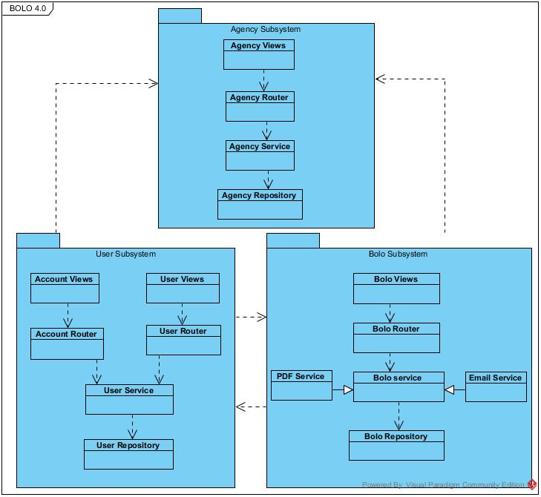

Figure 1 - Package diagram

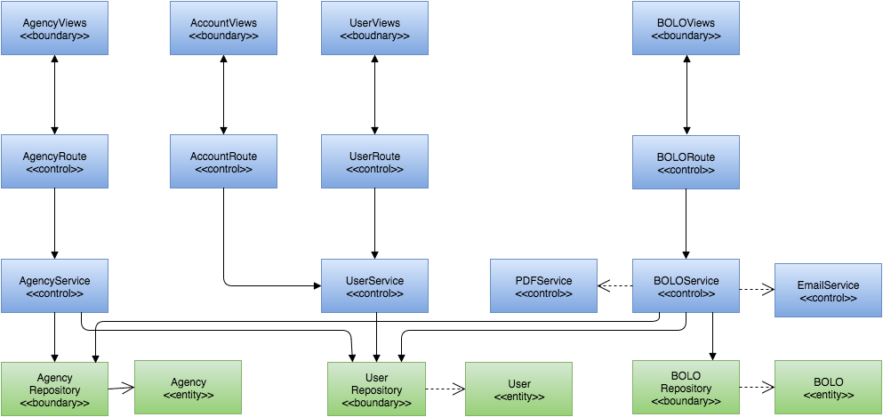

Figure 2 - Minimal class diagram

## Deployment Diagram

The system is deployed on an cloud platform known as IBM Bluemix server. It allows for personal computers and mobile devices to exchange HTTP requests with the domain. Cloudant serves as the main persistent storage.

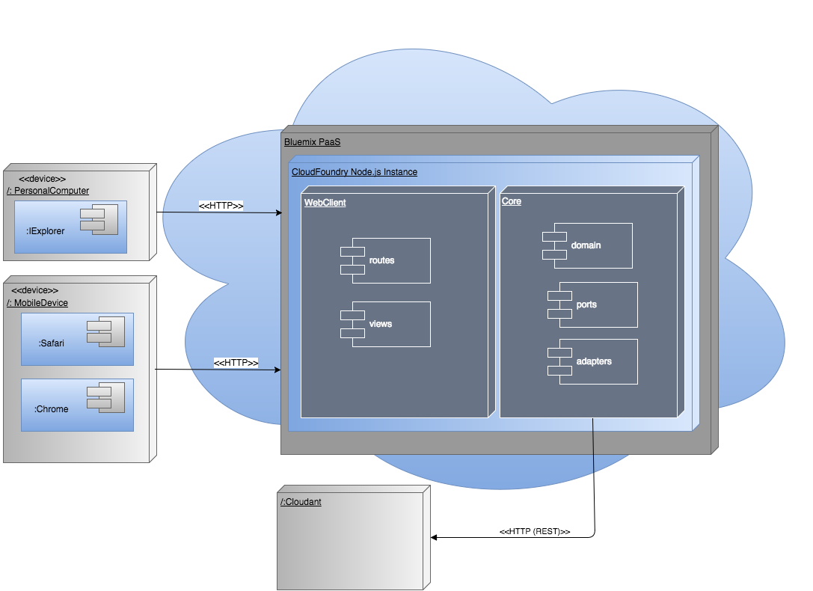

Figure 3 - General Deployment Diagram

## Design Patterns

The following design patterns were chosen during the last iteration of the system and they have been maintained for the current one:

* Observer: This is essential to maintain an organized execution of asynchronous calls in order to prevent the system from malfunctioning.
* Adapter: It is necessary to “adapt” the system to the services being utilized such as Sendgrid.
* Repository: This abstraction is used to mediate between the domain and the persistent data storage so that if the database service was to be changed, it can be done without altering the entire code.

# System Validation

Given that the system is multi-layered in terms of architecture, unit testing is easier to implement. The Mocha framework was utilized to implement some of them. This section contains all of the test cases that were written as features were being implemented.

**User Story #575 - Preview BOLO Before Creation**

Unit Tests

|  |
| --- |
| **Test ID**: U-575-01 |
| **Purpose:** To validate all entered information during BOLO creation is displayed in preview mode. |
| **Preconditions:** The user must be logged in. |
| **Input: ‘**Preview’ button is pressed with the following information:  Bolo({  category : 'ROBBERY',  firstName : 'Barry',  lastName : 'Badman',  dob : '01-23-1945',  dlNumber : 'D123-456-78-900-0',  race : 'Asian',  sex : 'M',  height : '6-01',  weight : '185',  hairColor : 'Black',  tattoos : 'Tomato tattoo on right chest',  address : '123 Gangsta Lane',  additional : '',  summary : '',  archive : false,  isActive : true  } |
| **Expected Output**: A Details page is rendered with all the current information being displayed. |

Integration Tests

|  |
| --- |
| **Test ID**: I-575-01 |
| **Purpose:** To validate that the system displays all the information entered when created a BOLO should the proper request be passed through the boloCreate route. |
| **Preconditions:** The user must be logged in. |
| **Input:**   * **‘**Preview’ button is pressed with the following information:   Bolo({  category : 'ROBBERY',  firstName : 'Barry',  lastName : 'Badman',  dob : '01-23-1945',  dlNumber : 'D123-456-78-900-0',  race : 'Asian',  sex : 'M',  height : '6-01',  weight : '185',  hairColor : 'Black',  tattoos : 'Tomato tattoo on right chest',  address : '123 Gangsta Lane',  additional : '',  summary : '',  archive : false,  isActive : true  }   * req.formDTO = ‘Preview’ * router.post( '/bolo/create', _bodyparser, function ( req, res, next ) |
| **Expected Output**: A Details page is rendered with all the current information being displayed. |

**User Story #589 - View BOLO Flier**

Unit tests

|  |
| --- |
| **Test ID**: U-589-01 |
| **Purpose:** To validate that the Details button renders a BOLO view. |
| **Preconditions:**   * User must be logged in the system. * At least one BOLO must be contained in the database. |
| **Input:** User clicks on ‘Details’ button. |
| **Expected Output**: The BOLO details view is displayed with all available information. |

|  |
| --- |
| **Test ID**: U-589-02 |
| **Purpose:** To validate that the BOLO details view can be rendered even if the BOLO has no attachments. |
| **Preconditions:**   * User must be logged in the system. * A BOLO without attachments is in the database. |
| **Input:** User clicks on the ‘Details’ button. |
| **Expected Output**: The BOLO is displayed with all available information and, instead of an uploaded picture, a ‘nopic.png’ as displayed image. |

Integration tests

|  |
| --- |
| **Test ID**: I-589-01 |
| **Purpose:** To validate that the system renders a BOLO view given that the BOLO information is contained in the request passed by getBoloDetails for the BOLO router. |
| **Preconditions:**   * User must be logged in the system. * At least one BOLO with the id field: ‘89012345678ee’ must be contained in the database. |
| **Input:**   * User clicks on ‘Details’ button. * Req{params{id = 89012345678ee}} * router.get( '/bolo/details/:id', function ( req, res, next ) |
| **Expected Output**: The BOLO details view is displayed with all available information. |

**User Story #593 - Search BOLOs**

Unit tests

|  |
| --- |
| **Test ID**: U-593-01 |
| **Purpose:** To validate that the proper BOLOs are filtered by the search query. |
| **Preconditions:** The user must be logged in. |
| **Input:** User fills out search form. |
| **Expected Output**: Bolos matching search criteria are rendered on the search results page. |

Integration tests

|  |
| --- |
| **Test ID**: I-593-01 |
| **Purpose:** To validate that the system correctly returns the proper Bolos when the search criteria is entered by the user. |
| **Preconditions:**   * The user must be logged in. * Bolos must exist to be searched against. |
| **Input:**   * User clicks on search tab * User enters search criteria in form. * Post search query to Database |
| **Expected Output**: Bolos matching search criteria are rendered on the search results page. |

**User Story #598 - Change Aesthetic Design of the System**

Unit tests

None required, as this is a change in aesthetic design.

Integration tests

None required, as this is a change in aesthetic design.

**User Story #602 - Purge BOLOs**

Unit tests

|  |
| --- |
| **Test ID**: U-602-01 |
| **Purpose:** To validate that user is authenticated to purge. |
| **Preconditions:** The user must be logged in as root. |
| **Input:**   * User goes to archive page. * User selects range from select menu. * User clicks purge button. * User enters password in authentication menu. |
| **Expected Output**: If password is valid, bolos matching selected criteria are purged. |

Integration tests

|  |
| --- |
| **Test ID**: I-602-01 |
| **Purpose:** To validate that the system allows a root user to purge bolos from the system when correct credentials are entered. |
| **Preconditions:**   * The user must be logged in as root. * Archived bolos exist. |
| **Input:**   * User clicks on archived bolos tab * User selects purge criteria. * User clicks Purge * User enters Password |
| **Expected Output**: Bolos matching criteria are purged from the system, the user is redirected back to the archive page which should now be empty. |

**User Story #603 - Edit Own BOLOs**

Unit tests

|  |
| --- |
| **Test ID**: U-603-1 |
| **Purpose:** Tests that the function updateBolo(updateDTO, attachments) updates a given bolo in database, as long as that bolo exists. |
| **Preconditions:** System must be fully functional and BOLO ‘bolo1’ must exist in database.  Bolo1 = {  id : 123,  createdOn : null,  lastUpdatedOn : null,  lastUpdatedBy : {},  agency : abc123,  agencyName : '',  author : '',  category : '',  firstName : '',  lastName : '',  dob : '',  dlNumber : '',  race : '',  sex : '',  height : '',  weight : '',  hairColor : '',  tattoos : '',  address : '',  additional : '',  summary : '',  attachments : {},  video_url : '',  isActive : true,  status : '',  images : {}  } |
| **Input:** updateBolo(bolo1, null); |
| **Expected Output**: Returns updated BOLO dto; BOLO is updated in database. |

|  |
| --- |
| **Test ID**: U-603-2 |
| **Purpose:** Tests that the function updateBolo(updateDTO, attachments) returns an error if the bolo provided does not exist. |
| **Preconditions:** System must be fully functional and BOLO ‘bolo1’ must not exist in database.  Bolo1 = {  id : 123,  createdOn : null,  lastUpdatedOn : null,  lastUpdatedBy : {},  agency : abc123,  agencyName : '',  author : '',  category : '',  firstName : '',  lastName : '',  dob : '',  dlNumber : '',  race : '',  sex : '',  height : '',  weight : '',  hairColor : '',  tattoos : '',  address : '',  additional : '',  summary : '',  attachments : {},  video_url : '',  isActive : true,  status : '',  images : {}  } |
| **Input:** updateBolo(bolo1, null); |
| **Expected Output**: Throws a not found error. |

Integration tests

|  |
| --- |
| **Test ID**: I-603-1 |
| **Purpose:** Tests that if a request with a valid bolo id and user is passed to the route ‘/bolo/edit/:id’, if the user created the bolo, the system will display the edit-bolo-form view. |
| **Preconditions:** System must be functional; Users "testUser1" and “testUser2” must exist in database. Bolo “bolo1” must exist in the database, created by testUser1. |
| **Input:**  Var req = {  ‘user’:’testUser1’,  ‘params’:(‘id’:’bolo1id’)  };  Var res = {};  getEditBoloForm(req, res); |
| **Expected Output**: Response contains redirect for edit-bolo-form view. |

|  |
| --- |
| **Test ID**: I-603-2 |
| **Purpose:** Tests that if a request with a valid bolo id and valid user is passed to the route ‘/bolo/edit/:id’, if the user did not create bolo, the system will display an error |
| **Preconditions:** System must be functional; Users "testUser1" and “testUser2” must exist in database. Bolo “bolo1” must exist in the database, created by testUser. |
| **Input:**  Var req = {  ‘user’:’testUser2’,  ‘params’:(‘id’:’bolo1id’)  };  Var res = {};  getEditBoloForm(req, res); |
| **Expected Output**: Response contains redirect for bolo-list view and a flash display for an ‘unauthorized’ error. |

**User Story #604 - Verify Archive**

Unit tests

|  |
| --- |
| **Test ID**: U-604-01 |
| **Purpose:** To validate that the user truly wants to archive a bolo. |
| **Preconditions:** The user must be logged in. |
| **Input:** User clicks on an archive button of bolo thumbnail |
| **Expected Output**: Verification window should appear asking user to confirm archive. |

Integration tests

|  |
| --- |
| **Test ID**: I-604-01 |
| **Purpose:** To validate that the process of archiving a bolo works as expected, including confirmation through dialog box. |
| **Preconditions:**   * The user must be logged in. * Bolos eligible for archiving should exist in the system. |
| **Input:**   * User clicks on the archive button on the thumbnail of bolo. * User clicks on confirm of archive confirmation dialog box. |
| **Expected Output**: Bolo should be archived and removed from active list of bolos. |

**User Story #606 - Update BOLO Instantly**

Unit tests

|  |
| --- |
| **Test ID**: U-606-01 |
| **Purpose:** Validating that the BOLO is updated after user clicks an update option if BOLO belongs to user. |
| **Preconditions:** A BOLO must exist in the database; That BOLO’s status must be set to “New”. User must exist in database. BOLO must belong to user. |
| **Input:** User clicks Update button and then clicks an option from the dropdown. |
| **Expected Output**: BOLO status is updated; System displays status in bold on BOLO flier. |

|  |
| --- |
| **Test ID**: U-606-02 |
| **Purpose:** Validating that the BOLO is not updated after user clicks an update option if the user does not own that BOLO or does not belong to the agency of the user that created the BOLO or is not tier 4. |
| **Preconditions:** A BOLO must exist in the database; There must exist a user (User1) registered with the system who is not a Root Administrator. The BOLO must not belong to User1 and must be from another agency. |
| **Input:** User clicks Update button and then clicks an option from the dropdown. |
| **Expected Output**: System displays error and redirects user. |

Integration tests

|  |
| --- |
| **Test ID**: U-606-01 |
| **Purpose:** Tests that a BOLO is updated if a valid request is sent to the route function boloUpdate(req, res) |
| **Preconditions:** User1 must exist in database and must be of Tier 1. BOLO must exist in database and must have been created by User1. |
| **Input:**  Var req = {“update”:”Cancelled”}  Var res = {}  boloUpdate(req, res); |
| **Expected Output**: BOLO status is updated; Response contains the redirect to bolo-list-view and the updated BOLO. |

|  |
| --- |
| **Test ID**: I-606-02 |
| **Purpose:** Tests that a BOLO is not updated if a request is sent by a user from a different agency. |
| **Preconditions:** A BOLO must exist in the database; There must exist a user (User1) registered with the system who is not a Root Administrator. The BOLO must not belong to User1 and must be from another agency. |
| **Input:**  Var req = {“update”:”Cancelled”}  Var res = {}  boloUpdate(req, res); |
| **Expected Output**: System displays error and response contains the redirect to bolo-list along with a flash with an error value. |

**User Story #607 - Sort Users**

Unit tests

|  |
| --- |
| **Test ID**: U-607-01 |
| **Purpose:** To validate that the user list can be sorted by name. |
| **Preconditions:** User has to be logged in as ‘root.’ |
| **Input:** Click on “Sort By Name”. |
| **Expected Output**: User List is organized by last name in descending order. |

|  |
| --- |
| **Test ID**: U-607-02 |
| **Purpose:** To validate that the user list can be sorted by username. |
| **Preconditions:** User has to be logged in as ‘root.’ |
| **Input:** Click on “Sort By Username”. |
| **Expected Output**: User List is organized by username in descending order. |

|  |
| --- |
| **Test ID**: U-607-03 |
| **Purpose:** To validate that the user list can be sorted by role. |
| **Preconditions:** User has to be logged in as ‘root.’ |
| **Input:** Click on “Sort By Role”. |
| **Expected Output**: User List is organized by role in descending order. |

|  |
| --- |
| **Test ID**: U-607-04 |
| **Purpose:** To validate that the user list can be sorted by agency. |
| **Preconditions:** User has to be logged in as ‘root.’ |
| **Input:** Click on “Sort By Agency”. |
| **Expected Output**: User List is organized by agency name in descending order. |

Integration tests

|  |
| --- |
| **Test ID**: I-607-01 |
| **Purpose:** To validate that the system can sort users by agency if the proper request is passed through getSortedList in the Admin users router. |
| **Preconditions:** User has to be logged in as ‘root.’ |
| **Input:**   * Click on “Sort By Agency”. * Req{params{id = ‘Agency’}} * module.exports.getSortedList = function ( req, res ) |
| **Expected Output**: User List is organized by agency name in descending order. |

**User Story #609 - Filter BOLOs By Agency**

Unit tests

|  |
| --- |
| **Test ID**: U-609-01 |
| **Purpose:** To validate that only Bolos from the selected agency are displayed. |
| **Preconditions:** The user must be logged in. |
| **Input:** User clicks on an agency. |
| **Expected Output**: Bolos from the selected agency are rendered on the homepage. |

Integration tests

|  |
| --- |
| **Test ID**: I-609-01 |
| **Purpose:** To validate that the system displays BOLOs only from the selected agency should the request contain proper information when being passed through getBoloAgency in the BOLO route. |
| **Preconditions:**   * The user must be logged in. * There is an agency in the system with id = ‘xyz.’ |
| **Input:**   * User clicks on an agency. * Req{params{id = ‘xyz’) * router.get( '/bolo/agency/:id', function ( req, res, next ) |
| **Expected Output**: Bolos from the selected agency are rendered on the homepage. |

**User Story #610 - Save as PDF**

Unit tests

Sunny Day:

|  |
| --- |
| **Test ID**: U-610-01 |
| **Purpose:** Validating whether generatedPDF ‘bolo.id.pdf’ is generated and written to the public/pdf directorywith correct input |
| **Preconditions:** bolo.data has been requested and received |
| **Input:** href=’/pdf/’ + bolo.id + ‘.pdf’ |
| **Expected Output**: bolo.id.pdf |

Rainy Day:

|  |
| --- |
| **Test ID**: U-610-02 |
| **Purpose:** Validating whether generatedPDF ‘bolo.id.pdf’ is generated and rendered to the to client browser |
| **Preconditions:** bolo.data has been requested and received |
| **Input:** href=’someNonsensical‘.pdf’  boloService attachement AgencyService attachment  boloService data |
| **Expected Output**: someNonsensical.pdf ( should not render based on ID work based on input ) |

**User Story #611 - Access BOLO Record tracking**

Unit tests

|  |
| --- |
| **Test ID**: U-611-01 |
| **Purpose:** To validate that the ‘View Record’ button is not visible if the BOLO has not been updated or edited. |
| **Preconditions:**   * User must be logged in the system. * A BOLO with an empty ‘record’ field must be contained in the database. |
| **Input:** User clicks on the ‘Details’ button that has an empty ‘record’ field. |
| **Expected Output**: The BOLO details view is displayed with all available information and the ‘View Record’ button is not visible. |

|  |
| --- |
| **Test ID**: U-611-02 |
| **Purpose:** To validate that the ‘View Record’ button renders BOLO records if the BOLO has been edited. |
| **Preconditions:**   * User must be logged in the system. * At least one BOLO that has been edited must be contained in the database. |
| **Input:** User clicks on ‘View Record’ button. |
| **Expected Output**: The BOLO ‘Record Tracking’ view is displayed with all available information. |

|  |
| --- |
| **Test ID**: U-611-03 |
| **Purpose:** To validate that the ‘View Record’ button renders BOLO records if the BOLO has been updated. |
| **Preconditions:**   * User must be logged in the system. * At least one BOLO that has been updated must be contained in the database. |
| **Input:** User clicks on ‘View Record’ button. |
| **Expected Output**: The BOLO ‘Record Tracking’ view is displayed with all available information. |

|  |
| --- |
| **Test ID**: U-611-04 |
| **Purpose:** To validate that the ‘View Record’ button renders BOLO records if the BOLO has been updated and edited. |
| **Preconditions:**   * User must be logged in the system. * At least one BOLO that has been updated and edited must be contained in the database. |
| **Input:** User clicks on ‘View Record’ button. |
| **Expected Output**: The BOLO ‘Record Tracking’ view is displayed with all available information. |

Integration tests

|  |
| --- |
| **Test ID**: I-611-01 |
| **Purpose:** To validate that the system displays records on a BOLO that has been edited or updated given that the correct request has been passed to boloDetailsRecord for the BOLO router. |
| **Preconditions:**   * User must be logged in the system. * A BOLO with the id field: ‘89012345678ee’ that has been edited or updated must be contained in the database. |
| **Input:**   * User clicks on the ‘View Record’ button. * Req{params{id = 89012345678ee}} * router.get('/bolo/details/record/:id', function (req, res, next) |
| **Expected Output**: The user is redirected to a view that contains the BOLO records. |

**User Story # 613 - Toggle Activation of an Agency**

Unit tests

|  |
| --- |
| **Test ID**: U-613-01 |
| **Purpose:** To deactivate an agency that is currently active in the system. |
| **Preconditions:** The user must be logged in. |
| **Input:** User clicks on deactivate button on agency edit form. |
| **Expected Output**: Status of agency is set to inactive. |

Integration tests

|  |
| --- |
| **Test ID**: I-613-01 |
| **Purpose:** To validate that the process of deactivating an agency works as expected. |
| **Preconditions:**   * The user must be logged in. * The user should be root. * Active Agencies should exist within the system. |
| **Input:**   * User clicks on the agency list link under the admin tab. * User clicks on one of the edit buttons for one of the active agencies on the list. * User clicks on the deactivate button for the current agency on the edit form. |
| **Expected Output**: Agency should be deactivated and users associated with that agency should not be able to access the system. |

**User Story # 615 - Search BOLO By Agency**

Unit tests

|  |
| --- |
| **Test ID**: U-615-01 |
| **Purpose:** To have the ability to search a bolo by the agency that created it. |
| **Preconditions:**   * The user must be logged in. * The user should be at the search page. |
| **Input:**   * User selects an agency in the agency select field. * User presses search button. |
| **Expected Output**: All bolos created by that agency should appear in search results page. |

Integration tests

|  |
| --- |
| **Test ID**: I-615-01 |
| **Purpose:** To validate that the process of searching a bolo by the agency that created it results in all matches being rendered in the search results page. |
| **Preconditions:**   * The user must be logged in. * User is at the search form page. |
| **Input:**   * User Selects an agency in the agency field. * User clicks on the search button. |
| **Expected Output**: Search page is rendered with all matching bolos. |

**User Story # 743 - Compress Image**

Unit tests

|  |
| --- |
| **Test ID**: U-743-01 |
| **Purpose:** System compresses image bigger than constant max size. |
| **Preconditions:** User is on create bolo page. |
| **Input:** User adds image to bolo. |
| **Expected Output**: Bolo is created with selected image(s) and compression is successful. |

Integration tests

|  |
| --- |
| **Test ID**: I-743-01 |
| **Purpose:** To validate that the process of compressing an image is handled correctly by the system. |
| **Preconditions:**   * The user is logged onto the system. |
| **Input:**   * User clicks on create new bolo tab in the bolo menu. * User adds an image greater than the maximum size allowed by the system. * User clicks create button. |
| **Expected Output**: System will convert image to jpeg format, if necessary. Size of image will then be evaluated and an appropriate level of compression will be applied. Compressed image will then be attached to the bolo and bolo will be created. |

**User Story # 750 - Create Agency**

Unit tests

|  |
| --- |
| **Test ID**: U-750-01 |
| **Purpose:** To validate that an agency cannot be created with empty fields. |
| **Preconditions:** User has to be logged in as ‘root.’ |
| **Input:** Form fields left empty. |
| **Expected Output**: An Error message is displayed. |

|  |
| --- |
| **Test ID**: U-750-02 |
| **Purpose:** To validate that an agency cannot be created if a field is left empty. |
| **Preconditions:** User has to be logged in as ‘root.’ |
| **Input:** All Form fields are filled except one. |
| **Expected Output**: An Error message is displayed.. |

|  |
| --- |
| **Test ID**: U-750-03 |
| **Purpose:** To validate that an agency can be created if all fields have content and attachments. |
| **Preconditions:**   * User has to be logged in as ‘root.’ * No agency in the database can have the name: ‘Pinecrest.’ * No agency in the database can have the ID: ‘001.’ |
| **Input:** The form is filled with the following values:  Agency{  “name”:”Pinecrest”,  “id”:”001”,  “address”:”testAddress”,  “phone”: “testPhone”,  “city”:”testCity”,  “state”:”testState”,  “zip”:”testZip”  “Attachments”: object  } |
| **Expected Output**: A message indicating success is displayed. |

|  |
| --- |
| **Test ID**: U-750-04 |
| **Purpose:** An agency cannot be created without attachments. |
| **Preconditions:**   * User has to be logged in as ‘root.’ * No agency in the database can have the name: ‘Pinecrest.’ * No agency in the database can have the ID: ‘001.’ |
| **Input:** The form is filled with the following values:  Agency{  “name”:”Pinecrest”,  “id”:”001”,  “address”:”testAddress”,  “phone”: “testPhone”,  “city”:”testCity”,  “state”:”testState”,  “zip”:”testZip”  “Attachments”: null  } |
| **Expected Output**: An error message is displayed. |

|  |
| --- |
| **Test ID**: U-750-05 |
| **Purpose:** Tests that an admin user can create an agency. |
| **Preconditions:** Database must not already contain agency from input. |
| **Input:** Agency1  {  “name”:”testAgency”,  “id”:”123”,  “address”:”testAddress”,  “phone”: “testPhone”,  “city”:”testCity”,  “state”:”testState”,  “zip”:”testZip”  } |
| **Expected Output**: System creates agency in Cloudant Database; System redirects user to {{base_url}}/admin/agency endpoint; System displays message confirming agency creation. |

|  |
| --- |
| **Test ID**: U-750-06 |
| **Purpose:** Tests that the system will reject a duplicate creation of an agency. |
| **Preconditions:** Database must already contain agency from input: AgencyServices.createAgency(Agency1, null); |
| **Input:** Agency1  {  “name”:”testAgency”,  “id”:”123”,  “address”:”testAddress”,  “phone”: “testPhone”,  “city”:”testCity”,  “state”:”testState”,  “zip”:”testZip”  } |
| **Expected Output**: System displays a “Duplicate Agency” error to user and does not create the agency. |

|  |
| --- |
| **Test ID**: U-750-07 |
| **Purpose:** Tests that a root admin user can create an agency if the agency name or id does not already exist in the database. |
| **Preconditions:** Database must not already contain agency from input: |
| **Input:** Agency1  {  “name”:”testAgency”,  “id”:”123”,  “address”:”testAddress”,  “phone”: “testPhone”,  “city”:”testCity”,  “state”:”testState”,  “zip”:”testZip”  } |
| **Expected Output**: System creates agency in Cloudant Database; System redirects user to {{base_url}}/admin/agency endpoint; System displays message confirming agency creation. |

|  |
| --- |
| **Test ID**: U-750-08 |
| **Purpose:** Tests that the system will reject a duplicate creation of an agency when the agency name exists. |
| **Preconditions:** Database must already contain agency name from input: AgencyServices.createAgency(Agency1, null); |
| **Input:** Agency1  {  “name”:”testAgency”,  “id”:”123”,  “address”:”testAddress”,  “phone”: “testPhone”,  “city”:”testCity”,  “state”:”testState”,  “zip”:”testZip”  } |
| **Expected Output**: System displays a “Duplicate Agency” error to user and does not create the agency. |

|  |
| --- |
| **Test ID**: U-750-09 |
| **Purpose:** Tests that the system will reject a duplicate creation of an agency when the agency id exists. |
| **Preconditions:** Database must already contain agency id from input: AgencyServices.createAgency(Agency1, null); |
| **Input:** Agency1  {  “name”:”testAgency”,  “id”:”123”,  “address”:”testAddress”,  “phone”: “testPhone”,  “city”:”testCity”,  “state”:”testState”,  “zip”:”testZip”  } |
| **Expected Output**: System displays a “Duplicate Agency” error to user and does not create the agency. |

Integration tests

|  |
| --- |
| **Test ID**: I-750-01 |
| **Purpose:** Tests that the system will create an agency given the correct request is passed to postCreateForm for the agency router. |
| **Preconditions:** System must be fully functional and user must be a Root Administrator. Agency name or id must not exist in database. |
| **Input:** var req = {  ‘agencyId’:’test123’,  ‘agencyName’:’testName’,  ‘city’:’testCity’,  ‘state’:’testState’,  ‘zip’:’12345’,  ‘Phone’:’1234566’,  ‘attachments’:[testAtt1, testAtt2]  };  Var res = {};  Var next = {};  agencyRouter.postCreateForm(req, res, next); |
| **Expected Output**: System creates the agency in the database and displays the agency on the response. User is redirected to agency-list view. |

|  |
| --- |
| **Test ID**: I-750-02 |
| **Purpose:** Tests that the system will not create an agency given the correct request is passed to postCreateForm for the agency router. |
| **Preconditions:** System must be fully functional and user must be a Root Administrator. Agency id must exist in database. |
| **Input:** var req = {  ‘agencyId’:’test123’,  ‘agencyName’:’testName’,  ‘city’:’testCity’,  ‘state’:’testState’,  ‘zip’:’12345’,  ‘Phone’:’1234566’,  ‘attachments’:[testAtt1, testAtt2]  };  Var res = {};  Var next = {};  agencyRouter.postCreateForm(req, res, next); |
| **Expected Output**: System displays a duplicate agency error and does not create the agency. |

|  |
| --- |
| **Test ID**: I-750-03 |
| **Purpose:** Tests that the system will reject a duplicate creation of an agency upon a valid request passed to the agency router. |
| **Preconditions:** Database must already contain Agency1. |
| **Input:** Agency1  {  “name”:”testAgency”,  “id”:”123”,  “address”:”testAddress”,  “phone”: “testPhone”,  “city”:”testCity”,  “state”:”testState”,  “zip”:”testZip”  };  Var res = {};  agencyRouter.postCreateForm(req(Agency1), res); |
| **Expected Output**: Response carries redirect value of agency-list view and a flash value of ‘duplicate agency error’. System does not create the agency. |

**User Story # 763 - Email New BOLO Notification**

Unit tests

Sunny Day:

|  |
| --- |
| **Test ID**: U-763-01 |
| **Purpose:** Validating whether sendgrid.send() bolo-notification email to subscribed users. |
| **Preconditions:** user_email has been requested and received |
| **Input:** (payload, function(err, json) ) |
| **Expected Output**: json object with status of operation - Success |

Rainy Day:

|  |
| --- |
| **Test ID**: U-763-02 |
| **Purpose:** Validating whether sendgrid.send bolo-notification email to subscribed users or returning errors. |
| **Preconditions:** user_email has been requested and received by helper functions |
| **Input:** (payload_ERRONEOUS, function(err, json) ) |
| **Expected Output**: console.log(err) |

**User Story # 779 - Edit Agency**

Unit tests

|  |
| --- |
| **Test ID**: U-779-01 |
| **Purpose:** To validate that an agency can be edited. |
| **Preconditions:** The user has root rights. There is, at least, one agency in the system. |
| **Input:** The Edit Agency form is filled with the following values:  Agency{  “name”:”Pinecrest”,  “address”:”testAddress”,  “phone”: “testPhone1”,  “city”:”testCity”,  “state”:”testState”,  “zip”:”testZip”  “Attachments”: object  } |
| **Expected Output**: A success message. |

|  |
| --- |
| **Test ID**: U-779-01 |
| **Purpose:** To validate that an agency cannot be edited if there are fields left blank. |
| **Preconditions:** The user has root rights. There is, at least, one agency in the system. |
| **Input:** The Edit Agency form is filled with the following values:  Agency{  “name”:”Pinecrest”,  “address”:”testAddress”,  “phone”: “testPhone”,  “city”:””,  “state”:”testState”,  “zip”:”testZip”  “Attachments”: object  } |
| **Expected Output**: An error message. |

Integration tests

|  |
| --- |
| **Test ID**: I-779-01 |
| **Purpose:** To validate that the system applies changes to an agency that has been edited should the proper request goes through postEditForm in the Admin Agency router . |
| **Preconditions:**   * The user has root rights. * There is, at least, one agency in the system. |
| **Input:**   * The Edit Agency form is filled with the following values:   Agency{  “name”:”Pinecrest”,  “address”:”testAddress”,  “phone”: “testPhone1”,  “city”:”testCity”,  “state”:”testState”,  “zip”:”testZip”  “Attachments”: object  }   * Req contains:   Agency{  “name”:”Pinecrest”,  “address”:”testAddress2”,  “phone”: “testPhone2”,  “city”:”testCity2”,  “state”:”testState”,  “zip”:”testZip”  “Attachments”: object  }   * module.exports.postEditForm = function ( req, res, next ) |
| **Expected Output**: A success message. |

**User Story # 781 - Render BOLO PDF Without Storing**

Unit tests

Sunny Day:

|  |
| --- |
| **Test ID**: U-781-01 |
| **Purpose:** Validating whether generatedPDF ‘bolo.id.pdf’ is generated and rendered to the browser |
| **Preconditions:** boloForm data has been posted and parsed |
| **Input:** data{bolo, agency, user, attachments} |
| **Expected Output**: render(PDFView) |

Rainy Day:

|  |
| --- |
| **Test ID**: U-781-02 |
| **Purpose:** Validating whether generatedPDF ‘bolo.id.pdf’ is generated and rendered to the browser |
| **Preconditions:** bolo.data has been requested and received |
| **Input:** data{null} |
| **Expected Output**: invalidData() |

Integration tests

|  |
| --- |
| **Test ID**: I-781-01 |
| **Purpose:** Tests that if that with valid data being passed to the parseFormData(req, attachmentFilter), the system will generate a PDF using the provided bolo form input and that PDF is properly rendered to the view |
| **Preconditions:** bolo.data has been posted to the system |
| **Input:(req, attachmentFilter)** data={req.data.createdOn, req.data.LastUpdatedOn, req.data.agency, req.data.author, req.data.lastUpdatedBy.lastName, req.data.user.agencyName} attachment= [featuredImage] |
| **Expected Output**: doc (PDFDocument) with parsed data, system sends response with contentType = “application/pdf”, content=doc |

**User Story # 811 - Access BOLO Thumbnail Information**

Unit tests

|  |
| --- |
| **Test ID**: U-811-01 |
| **Purpose:** To validate that a list of all active Bolos is displayed on the homepage after successful log in. |
| **Preconditions:**   * A user logs in successfully. * There is at least one Bolo in the database. |
| **Input:** User logs in. |
| **Expected Output**: All active BOLOs are displayed with their proper action buttons. |

Integration tests

|  |
| --- |
| **Test ID**: I-811-01 |
| **Purpose:** To validate that the system displays a list of all active Bolos on the homepage after successful log in should the proper request be passed through getBolos in the Bolo router. |
| **Preconditions:**   * A user logs in successfully. * There is at least one Bolo in the database. |
| **Input:**   * User logs in. * Req.query.page != null |
| **Expected Output**: All active BOLOs are displayed with their proper action buttons. |

**User Story # 812 - Reset Forgotten Password**

Unit tests

|  |
| --- |
| **Test ID**: U-812-1 |
| **Purpose:** Tests that if the user provides an email that is registered in the system, the function getByEmail(email) will return the user that the email corresponds to. |
| **Preconditions:** System must be functional; User "testUser" must exist in database.  testUser =  {  "username": "testUser",  "password": "Password1!",  "fname" : "test",  "lname" : "user",  "email": "test@example.com",  "tier": 1,  "agency": "testAgency123",  "agencyName" : "testAgency123"  } |
| **Input:** userRepository.getByEmail("test@example.com"); |
| **Expected Output**: testUser |

|  |
| --- |
| **Test ID**: U-812-2 |
| **Purpose:** Tests that if the user provides an email that is not registered in the system, the function will return null. |
| **Preconditions:** System must be functional; User "testUser" must exist in database.  testUser =  {  "username": "testUser",  "password": "Password1!",  "fname" : "test",  "lname" : "user",  "email": "test@example.com",  "tier": 1,  "agency": "testAgency123",  "agencyName" : "testAgency123"  } |
| **Input:** userRepository.getByEmail("test1@example.com"); |
| **Expected Output**: null |

|  |
| --- |
| **Test ID**: U-812-3 |
| **Purpose:** Tests that if the user provides a valid passwordResetToken, the function getByToken(token) will return the user that the passwordResetToken corresponds to. |
| **Preconditions:** System must be functional; User "testUser" must exist in database.  testUser =  {  "username": "testUser",  "password": "Password1!",  "fname" : "test",  "lname" : "user",  "email": "test@example.com",  "tier": 1,  "agency": "testAgency123",  "agencyName" : "testAgency123",  "passwordResetToken":"testToken123",  } |
| **Input:** userRepository.getByToken("testToken123"); |
| **Expected Output**: testUser |

|  |
| --- |
| **Test ID**: U-812-4 |
| **Purpose:** Tests that if the user provides an invalid passwordResetToken, the function getByToken(token) will return null. |
| **Preconditions:** System must be functional; User "testUser" must exist in database.  testUser =  {  "username": "testUser",  "password": "Password1!",  "fname" : "test",  "lname" : "user",  "email": "test@example.com",  "tier": 1,  "agency": "testAgency123",  "agencyName" : "testAgency123",  "passwordResetToken":"testToken123",  } |
| **Input:** userRepository.getByToken("testToken124"); |
| **Expected Output**: null |

|  |
| --- |
| **Test ID**: U-812-5 |
| **Purpose:** Tests that if the user provides a registered user id and a password, the user's password is reset to the provided password. |
| **Preconditions:** System must be functional; User "testUser" must exist in database.  testUser =  {  "id":"12345"  "username": "testUser",  "password": "Password1!",  "fname" : "test",  "lname" : "user",  "email": "test@example.com",  "tier": 1,  "agency": "testAgency123",  "agencyName" : "testAgency123",  "passwordResetToken":"testToken123",  } |
| **Input:** userService.resetPassword("12345", "Password2@"); |
| **Expected Output**:  testUser =  {  "id":"12345"  "username": "testUser",  "password": "Password2@",  "fname" : "test",  "lname" : "user",  "email": "test@example.com",  "tier": 1,  "agency": "testAgency123",  "agencyName" : "testAgency123",  "passwordResetToken":"testToken123",  } |

|  |
| --- |
| **Test ID**: U-812-6 |
| **Purpose:** Tests that if the user provides a nonregistered user id and a password, the system will throw an error. |
| **Preconditions:** System must be functional; User "testUser" must exist in database.  testUser =  {  "id":"12345"  "username": "testUser",  "password": "Password1!",  "fname" : "test",  "lname" : "user",  "email": "test@example.com",  "tier": 1,  "agency": "testAgency123",  "agencyName" : "testAgency123",  "passwordResetToken":"testToken123",  } |
| **Input:** userService.resetPassword("12346", "Password2@"); |
| **Expected Output**: "Error: Unable to get current user data. ID does not match records." |

Integration tests

|  |
| --- |
| **Test ID**: I-812-1 |
| **Purpose:** Tests that if a request with a valid email is passed into postForgotPassword(req, res), the system will update the user with a unique resetPasswordToken, a new timeout for resetPasswordExpires, send an email to the user with a link to where they can change their password, and redirect the user to the login page, along with displaying a success message. |
| **Preconditions:** System must be functional; User "testUser" must exist in database.  testUser =  {  "username": "testUser",  "password": "Password1!",  "fname" : "test",  "lname" : "user",  "email": "test@example.com",  "tier": 1,  "agency": "testAgency123",  "agencyName" : "testAgency123"  } |
| **Input:** postForgotPassword({"email":"test@example.com"}, mock(res)); |
| **Expected Output**: user resetPasswordToken is set to a unique uuid; user resetPasswordExpires is set to the current time + 1 hour; system sends email to user email; response redirect is set to 'login' page and success message is displayed. |

|  |
| --- |
| **Test ID**: I-812-2 |
| **Purpose:** Tests that if a request with an invalid email is passed into postForgotPassword(req, res), the system will display an error message. |
| **Preconditions:** System must be functional; User "testUser" must exist in database.  testUser =  {  "username": "testUser",  "password": "Password1!",  "fname" : "test",  "lname" : "user",  "email": "test@example.com",  "tier": 1,  "agency": "testAgency123",  "agencyName" : "testAgency123"  } |
| **Input:** postForgotPassword({"email":"test1@example.com"}, mock(res)); |
| **Expected Output**: response redirect is set to 'back' and error message is displayed in request. |

|  |
| --- |
| **Test ID**: I-812-3 |
| **Purpose:** Tests that if a request with a valid token as a parameter is passed into getChangePassword(req, res) then the system will redirect the user to allow them to change their password. |
| **Preconditions:** System must be functional; User "testUser" must exist in database.  testUser =  {  "username": "testUser",  "password": "Password1!",  "fname" : "test",  "lname" : "user",  "email": "test@example.com",  "tier": 1,  "agency": "testAgency123",  "agencyName" : "testAgency123",  "resetPasswordToken":"testToken123",  "resetPasswordExpires":1488429732  } |
| **Input:** postForgotPassword({"params":{"token":"testToken123"}}, mock(res)); |
| **Expected Output**: response redirect is set to 'change-password'. |

|  |
| --- |
| **Test ID**: I-812-4 |
| **Purpose:** Tests that if a request with an invalid token as a parameter is passed into getChangePassword(req, res) then the system will redirect the to the forgot-password view and display an error. |
| **Preconditions:** System must be functional; User "testUser" must exist in database.  testUser =  {  "username": "testUser",  "password": "Password1!",  "fname" : "test",  "lname" : "user",  "email": "test@example.com",  "tier": 1,  "agency": "testAgency123",  "agencyName" : "testAgency123",  "resetPasswordToken":"testToken123",  "resetPasswordExpires":1488429732  } |
| **Input:** postForgotPassword({"params":{"token":"testToken1234"}}, mock(res)); |
| **Expected Output**: response redirect is set to '/forgotPassword'; request contains error message. |

|  |
| --- |
| **Test ID**: I-812-5 |
| **Purpose:** Tests that if a request with a valid password and confirmed password is passed into postChangePassword(req, res), along with a valid user id, the system will reset the password of the user that corresponds to the given id. |
| **Preconditions:** System must be functional; User "testUser" must exist in database.  testUser =  {  "id":"12345",  "username": "testUser",  "password": "Password1!",  "fname" : "test",  "lname" : "user",  "email": "test@example.com",  "tier": 1,  "agency": "testAgency123",  "agencyName" : "testAgency123",  "resetPasswordToken":"testToken123",  "resetPasswordExpires":1488429732  } |
| **Input:** postForgotPassword({"params":{"id":"12345"}, "password":"Password2@", "confirm":"Password2@"}, mock(res)); |
| **Expected Output**: System changed password of testUser to be "Password2@". Response redirect is set to "login" and a success message is displayed. |

|  |
| --- |
| **Test ID**: I-812-6 |
| **Purpose:** Tests that if a request with non-matching password and confirmed password is passed into postChangePassword(req, res), along with a valid user id, the system will display a matching error. |
| **Preconditions:** System must be functional; User "testUser" must exist in database.  testUser =  {  "id":"12345",  "username": "testUser",  "password": "Password1!",  "fname" : "test",  "lname" : "user",  "email": "test@example.com",  "tier": 1,  "agency": "testAgency123",  "agencyName" : "testAgency123",  "resetPasswordToken":"testToken123",  "resetPasswordExpires":1488429732  } |
| **Input:** postForgotPassword({"params":{"id":"12345"}, "password":"Password2@", "confirm":"Password3@"}, mock(res)); |
| **Expected Output**: System redirects user back to page and displays matching error. |

**User Story # 814 - Application Timeout**

Unit tests

|  |
| --- |
| **Test ID**: U-814-01 |
| **Purpose:** To validate application times out. |
| **Preconditions:** The user must be logged in. |
| **Input:** User remains inactive for over 5 mins. |
| **Expected Output**: Session expires, user is booted to login page upon new http request. |

Integration tests

|  |
| --- |
| **Test ID**: I-814-01 |
| **Purpose:** To validate session expires. |
| **Preconditions:**   * The user account is valid |
| **Input:**   * User enters credentials and logs onto the system. * User remains inactive for over 5 minutes. |
| **Expected Output**: Session should expire, user booted back to the login page. |

**User Story # 820 - Edit BOLO within Agency**

Unit tests

|  |
| --- |
| **Test ID**: U-820-1 |
| **Purpose:** Tests that the function authorizedToEdit() returns true if a BoloAuthorize object is created with an author from the same agency and of a lower tier. |
| **Preconditions:** Users ‘User1’ and ‘User2’ are created in the database. ‘User1’ is of Tier 1 , agency: 123 and ‘User2’ is of Tier 2, agency: 123. A BOLO ’bolo1’ exists in the database, created by ‘User1’.  Var auth = new BoloAuthorize(bolo1, User1, User2); |
| **Input:** auth.authorizedToEdit(); |
| **Expected Output**: Returns true. |

|  |
| --- |
| **Test ID**: U-820-2 |
| **Purpose:** Tests that the function authorizedToEdit() returns false if a BoloAuthorize object is created with an author from a different agency and of a lower tier. |
| **Preconditions:** Users ‘User1’ and ‘User2’ are created in the database. ‘User1’ is of Tier 1 , agency: 123 and ‘User2’ is of Tier 2, agency: 456. A BOLO ’bolo1’ exists in the database, created by ‘User1’.  Var auth = new BoloAuthorize(bolo1, User1, User2); |
| **Input:** auth.authorizedToEdit(); |
| **Expected Output**: Returns false. |

|  |
| --- |
| **Test ID**: U-820-3 |
| **Purpose:** Tests that the function authorizedToEdit() returns false if a BoloAuthorize object is created with an author from the same agency and of an equal tier. |
| **Preconditions:** Users ‘User1’ and ‘User2’ are created in the database. ‘User1’ is of Tier 2 , agency: 123 and ‘User2’ is of Tier 2, agency: 123. A BOLO ’bolo1’ exists in the database, created by ‘User1’.  Var auth = new BoloAuthorize(bolo1, User1, User2); |
| **Input:** auth.authorizedToEdit(); |
| **Expected Output**: Returns false. |

Integration tests

|  |
| --- |
| **Test ID**: I-820-1 |
| **Purpose:** Tests that if a request with a valid bolo id and user is passed to the route ‘/bolo/edit/:id’, if the user belongs to the same agency and is of a higher tier than the author of the bolo, user will be redirected to the bolo-edit form. |
| **Preconditions:** Users ‘User1’ and ‘User2’ are created in the database. ‘User1’ is of Tier 2 , agency: 123 and ‘User2’ is of Tier 2, agency: 123. A BOLO ’bolo1’ exists in the database, created by ‘User1’. |
| **Input:**  Var req = {  ‘user’:’testUser2’,  ‘params’:(‘id’:’bolo1id’)  };  Var res = {};  getEditBoloForm(req, res); |
| **Expected Output**: Response contains redirect for edit-bolo-form view. |

|  |
| --- |
| **Test ID**: I-820-2 |
| **Purpose:** Tests that if a request with a valid bolo id and valid user is passed to the route ‘/bolo/edit/:id’, if the user belongs to a different agency and is of a higher tier than the author of the bolo, the system will display an error and not let let the user edit the bolo. |
| **Preconditions:** Users ‘User1’ and ‘User2’ are created in the database. ‘User1’ is of Tier 2 , agency: 123 and ‘User2’ is of Tier 2, agency: 456. A BOLO ’bolo1’ exists in the database, created by ‘User1’. |
| **Input:**  Var req = {  ‘user’:’testUser2’,  ‘params’:(‘id’:’bolo1id’)  };  Var res = {};  getEditBoloForm(req, res); |
| **Expected Output**: Response contains redirect for bolo-list view and a flash display for an ‘unauthorized’ error. |

**User Story # 821 - Create User within Agency**

Unit tests

|  |
| --- |
| **Test ID**: U-821-1 |
| **Purpose:** Assure that a user can be created if the user does not already exist. |
| **Preconditions:** System must be functional |
| **Input:** New user with specified criteria:  User1 {  Username: “leotest1”,  AgencyId : “abc123”,  Email: “example@example.com”  } |
| **Expected Output**: System creates user in database and redirects current user to user-list view |

|  |
| --- |
| **Test ID**: U-821-2 |
| **Purpose:** Assure that a user cannot be created if the user exists in database. |
| **Preconditions:** System must be functional and User1 must exist in database. |
| **Input:** New user with specified criteria:  User1 {  Username: “leotest1”,  AgencyId : “abc123”,  Email: “example@example.com”  } |
| **Expected Output**: System displays a duplicate error. |

Integration tests

|  |
| --- |
| **Test ID**: I-821-1 |
| **Purpose:** Tests that an Administrator can only create a user within their own agency |
| **Preconditions:** System must be functional and User1 must not exist in database. |
| **Input:** New user with specified criteria:  User1 {  Username: “leotest1”,  AgencyId : “abc123”,  Email: “example@example.com”  }  userRouter.postCreateForm(req(User1), res); |
| **Expected Output**: User is created in the database and is displayed in user-list. Res contains redirect to user-list view. |

|  |
| --- |
| **Test ID**: I-821-2 |
| **Purpose:** Tests that an Administrator can only create a user at or below their own tier. |
| **Preconditions:** System must be functional and User1 must not exist in database. |
| **Input:** New user with specified criteria:  User1 {  Username: “leotest1”,  AgencyId : “abc123”,  Email: “[example@example.com](mailto:example@example.com)”,  Tier : 2  }  userRouter.postCreateForm(req(User1), res); |
| **Expected Output**: User is created in the database and is displayed in user-list. Res contains redirect to user-list view. |

|  |
| --- |
| **Test ID**: I-821-3 |
| **Purpose:** Tests that an Administrator cannot create a user if that user already exists. |
| **Preconditions:** System must be functional and User1 must exist in database. |
| **Input:** New user with specified criteria:  User1 {  Username: “leotest1”,  AgencyId : “abc123”,  Email: “[example@example.com](mailto:example@example.com)”,  Tier : 2  }  userRouter.postCreateForm(req(User1), res); |
| **Expected Output**: Response contains flash error and redirect to unauthorized view. |

# Glossary

**Administrator**: A police agent that operates from a desk coordinating and overviewing tasks.

**Agency**: A district-based police department.

**BOLO:** A Be-on-the-lookout flyer that contains information about a specific crime.

**Officer**: A police agent assigned to a crime scene.

**Supervisor:** A field operator in charge of multiple cases.

**Root Administrator**: An officer that has universal access to a system used in law enforcement.

# Appendix

## Appendix A - UML Diagrams

### Static UML Diagrams

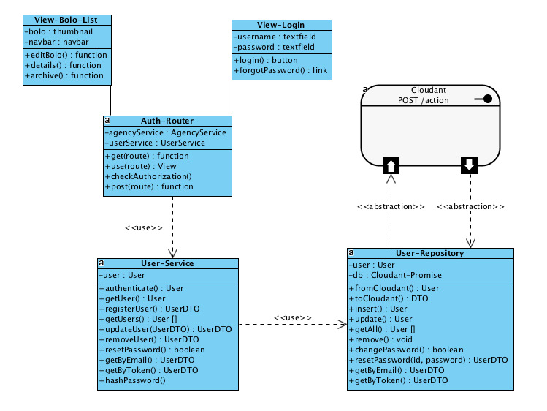

Figure 1 - Class diagram for Viewing Aesthetic Design of Sytem

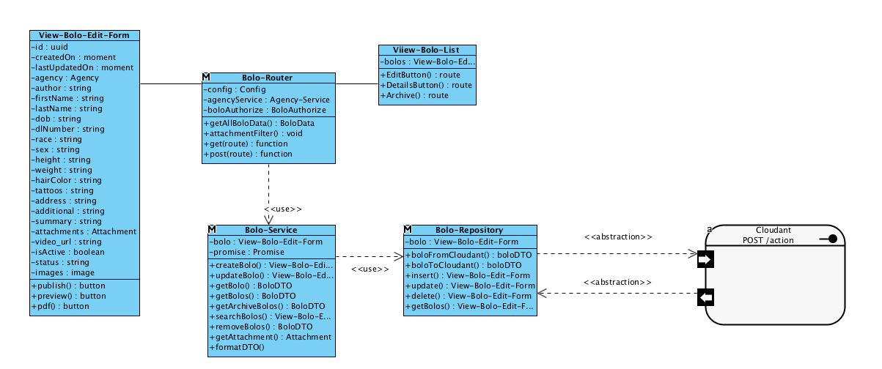

Figure 2 - Class Diagram for Edit Own BOLO

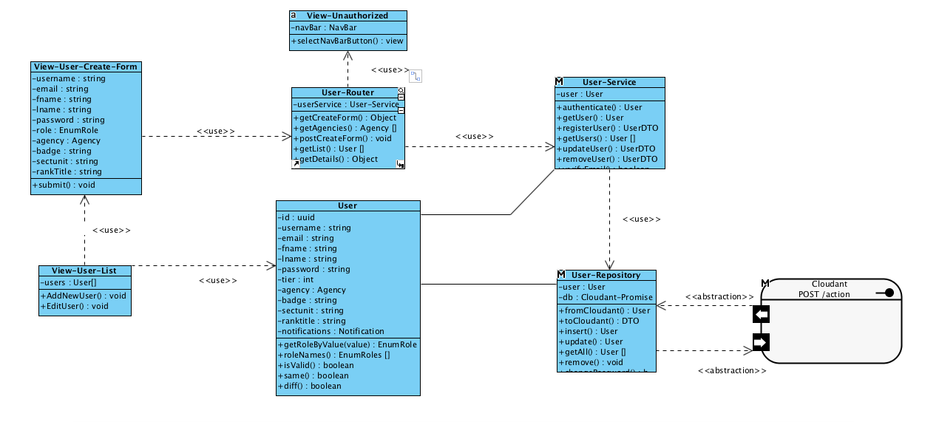

Figure 3 - Class diagram for Create User Within Agency

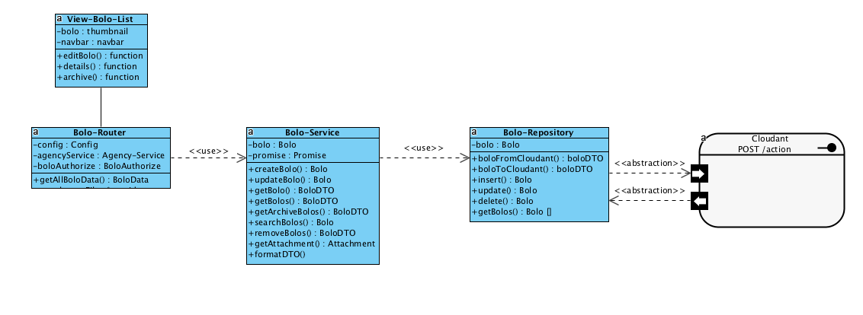

Figure 4 - Class diagram for Update BOLO Instantly

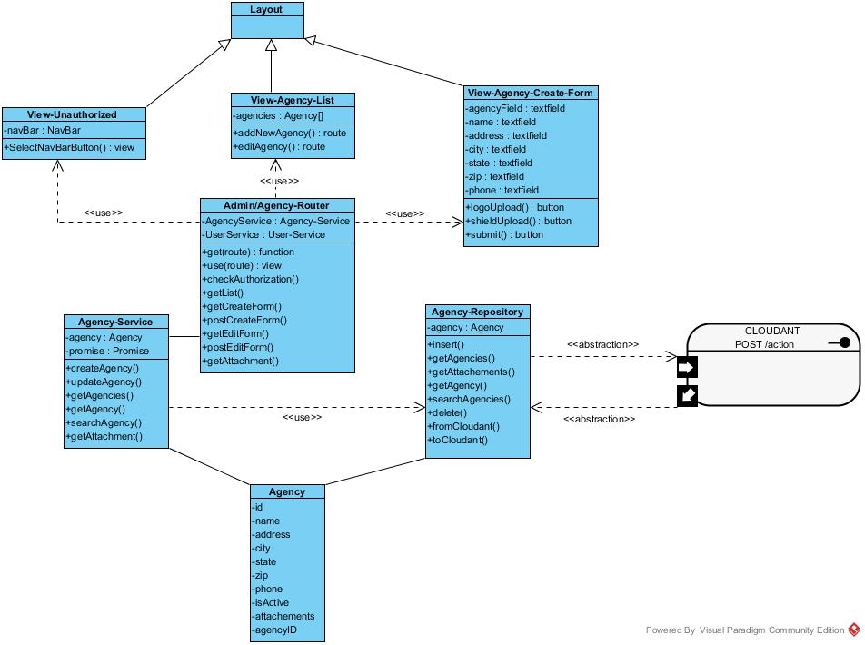

Figure 5 - Class diagram for Create Agency

Figure 6 - Class diagram for Preview BOLOs Before Creation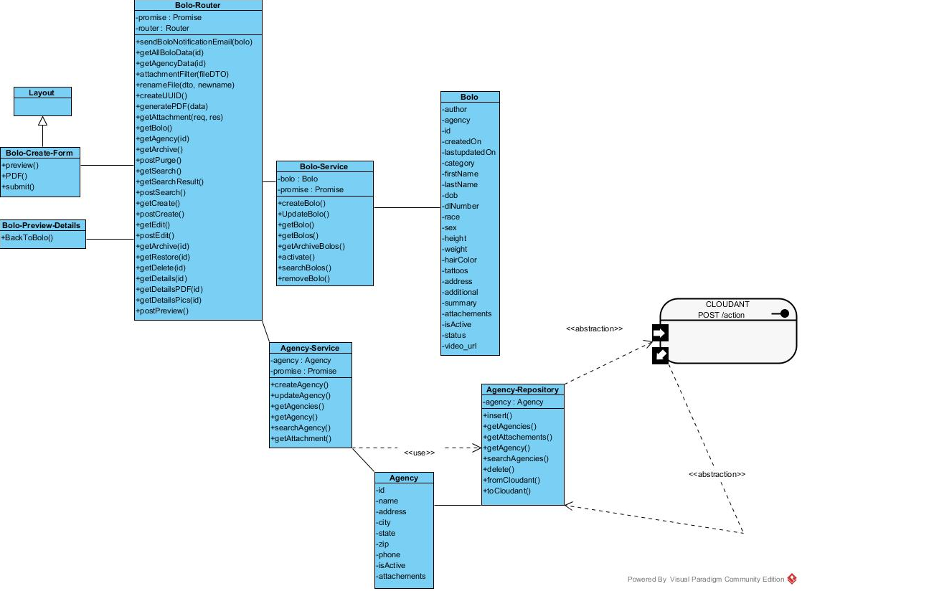

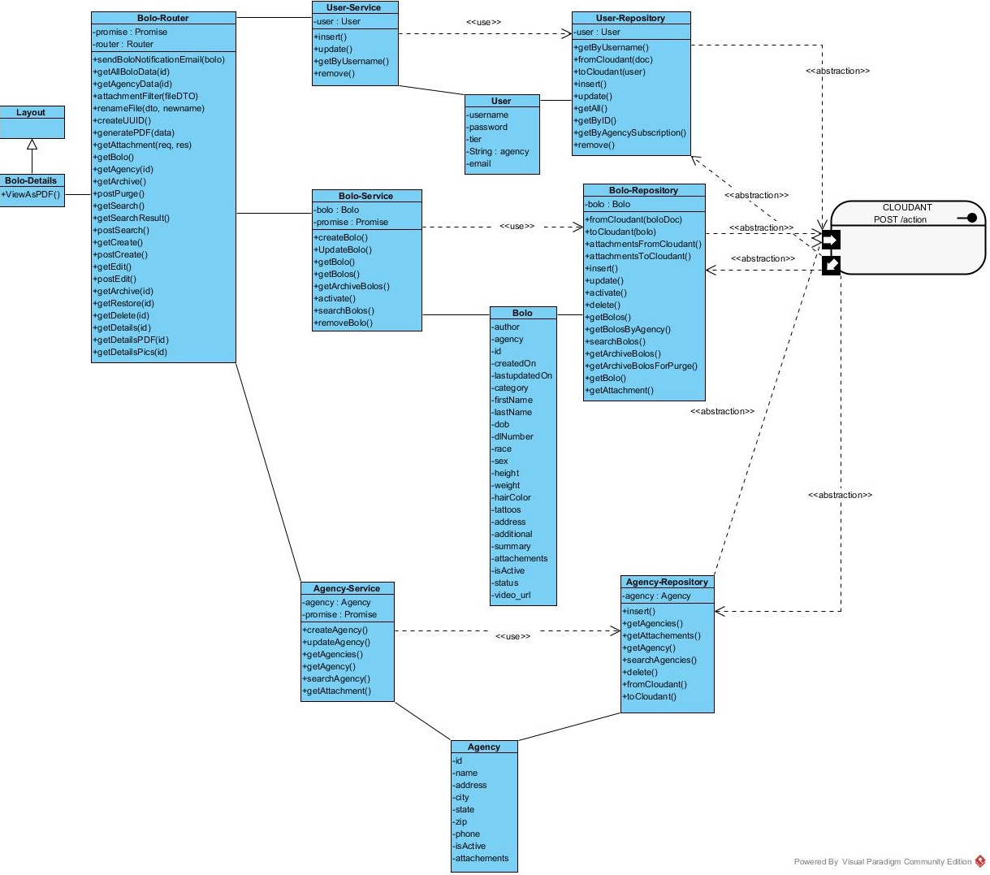

Figure 7 - Class diagram for View BOLO Flyer

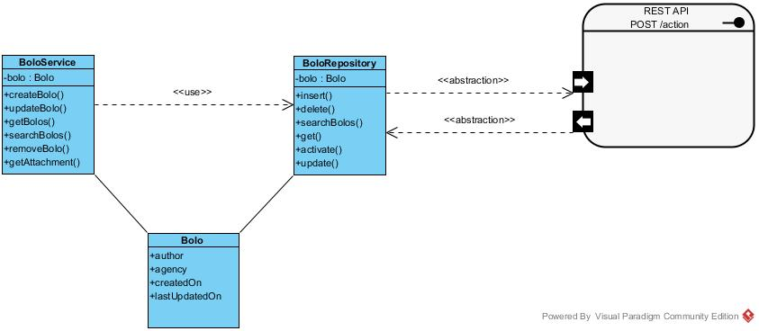

Figure 8 - Class diagram for Search BOLOs

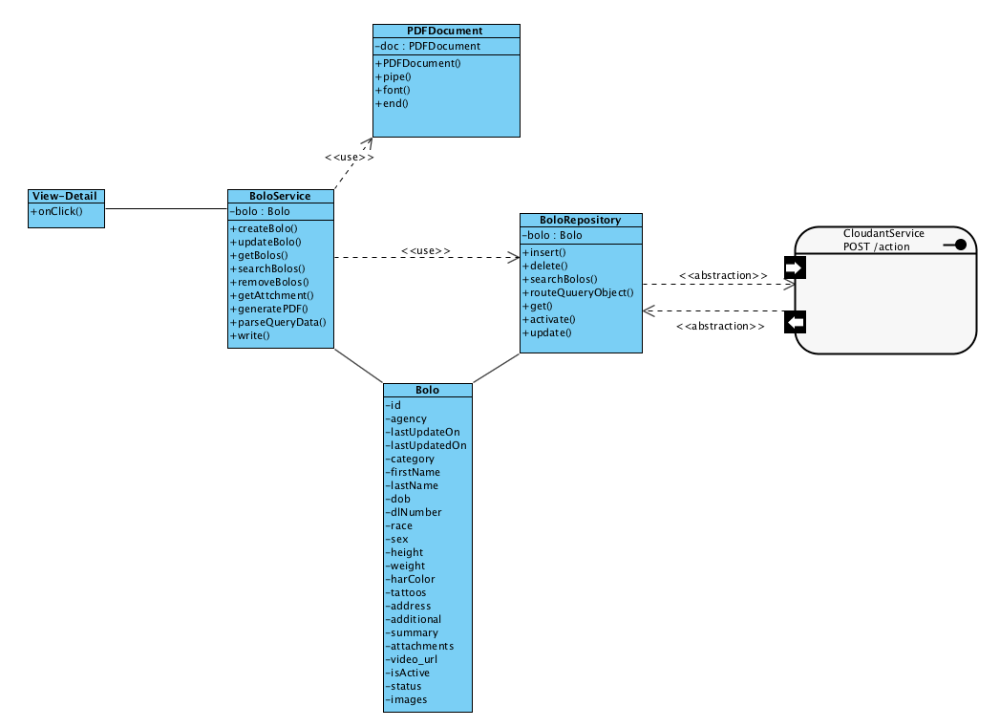

Figure 9 - Class diagram for Save as PDF

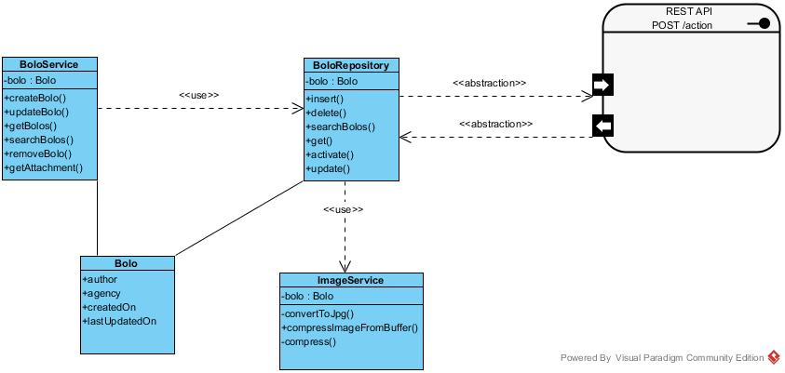

Figure 10 - Class diagram for Compress Image

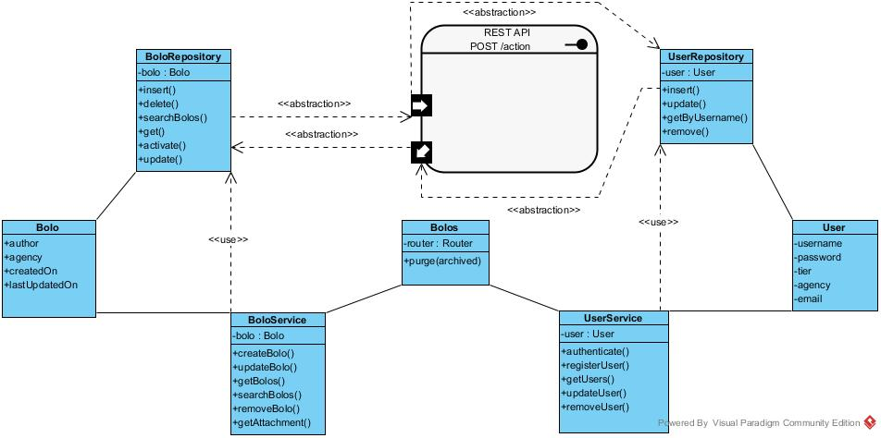

Figure 11 - Class diagram for Purge Archived BOLOs

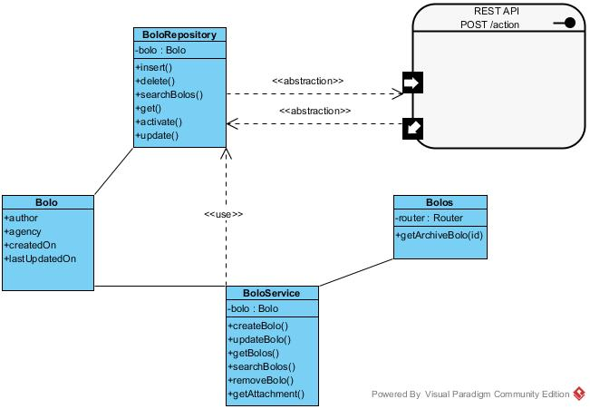

Figure 12 - Class diagram for Verify Archive BOLO

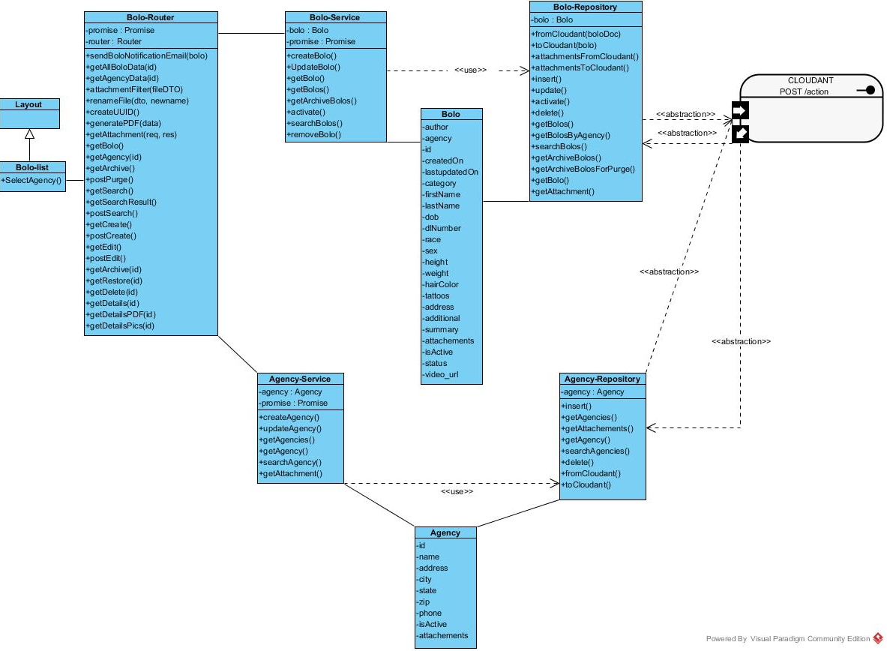

Figure 13 - Class diagram for Filter BOLOs By Agency

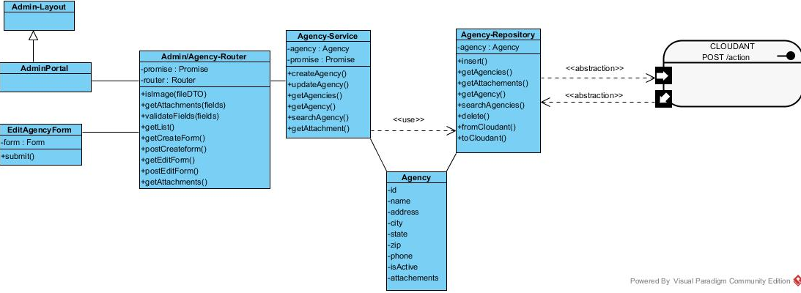

Figure 14 - Class diagram for Edit Agency



Figure 15 - Class diagram for Edit BOLO Within Agency

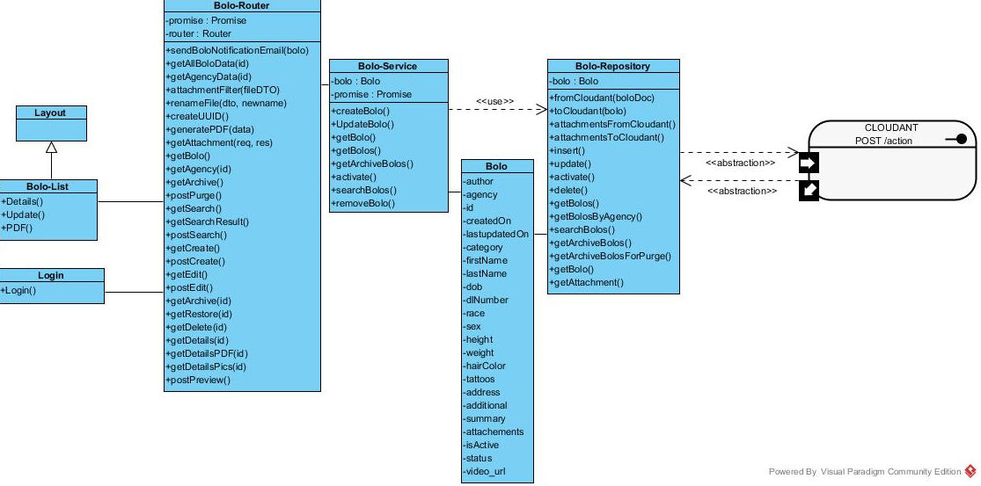

Figure 16 - Class diagram for Access BOLO Thumbnail Information

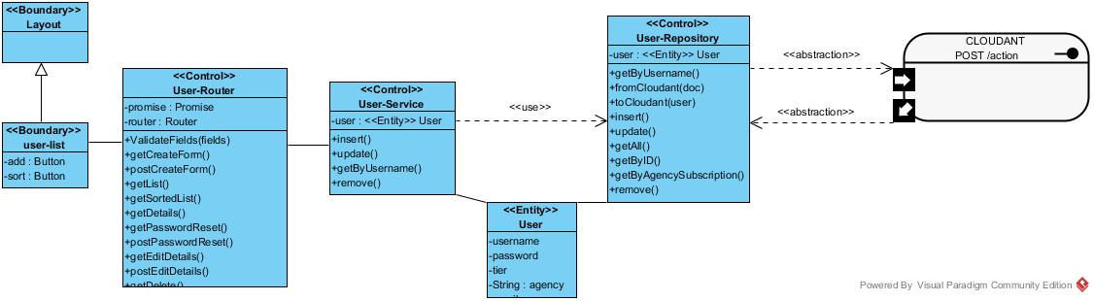

Figure 17 - Class diagram for Sort Users

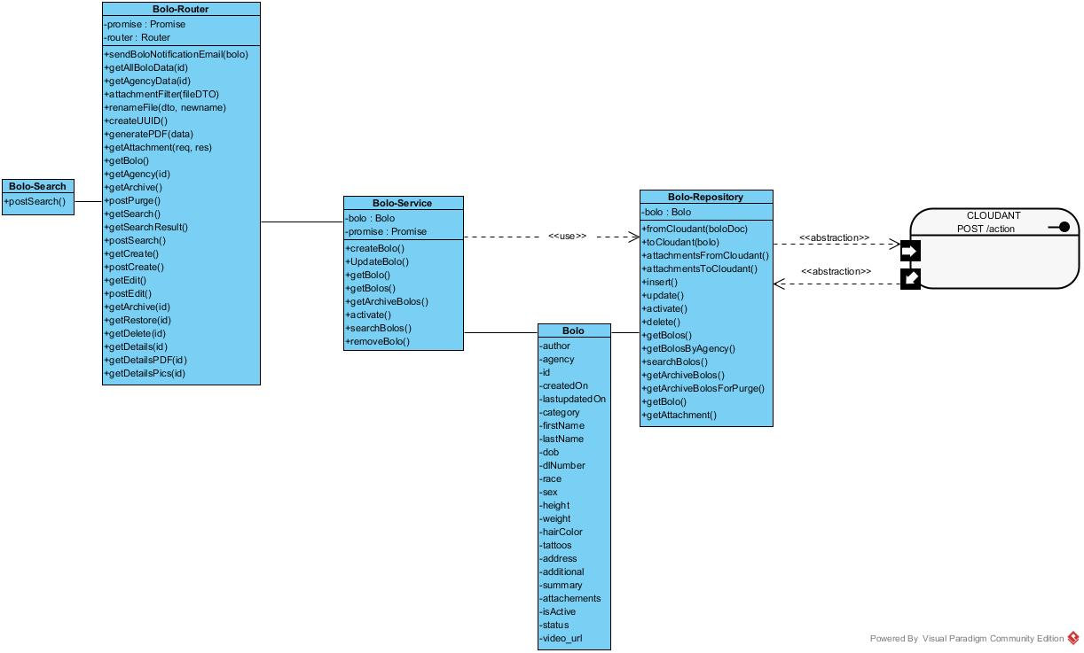

Figure 18 - Class diagram for Search BOLO By Agency

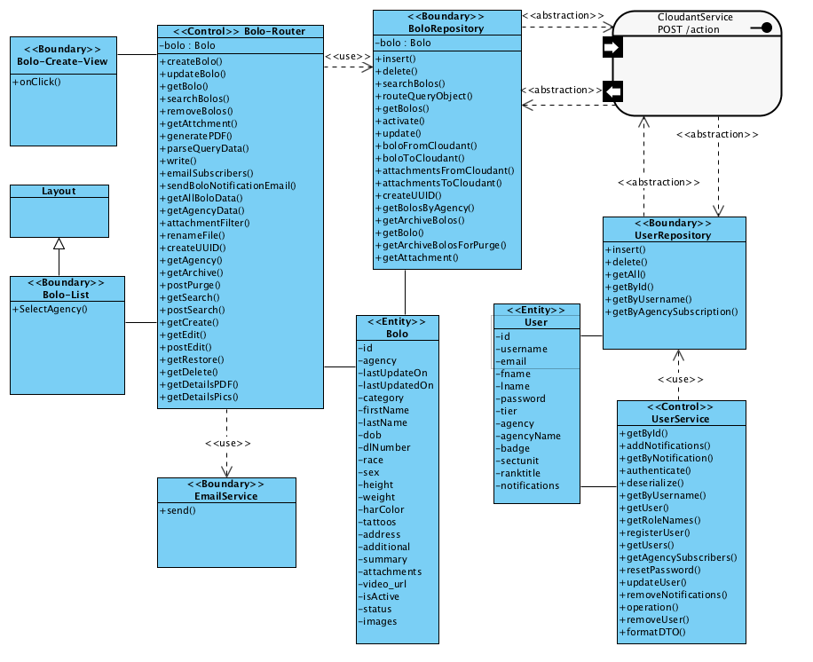

Figure 19 - Class diagram for Email New BOLO Notification

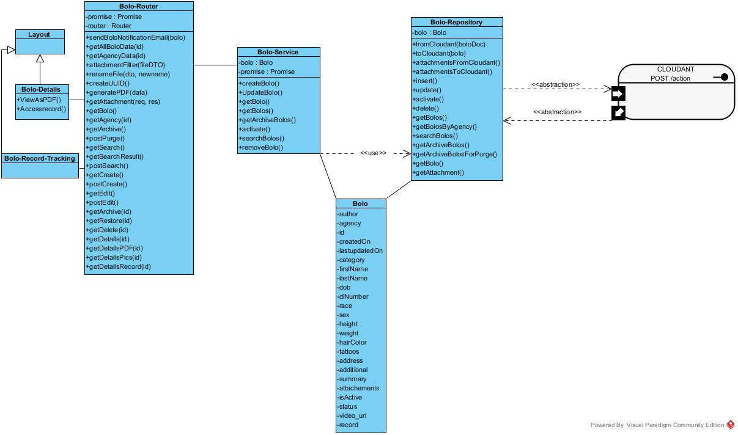

Figure 20 - Class diagram for Access BOLO Record Tracking

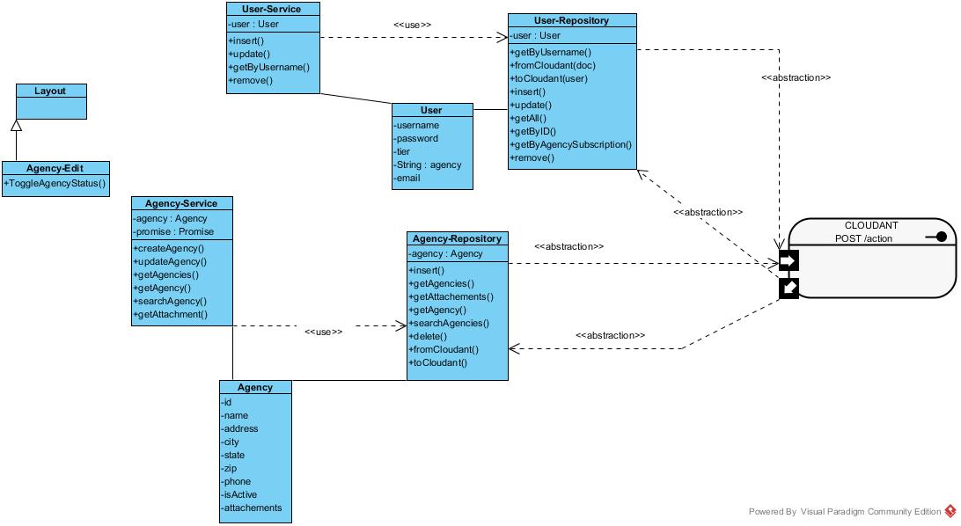

Figure 21 - Class diagram for Toggle Activation of an Agency

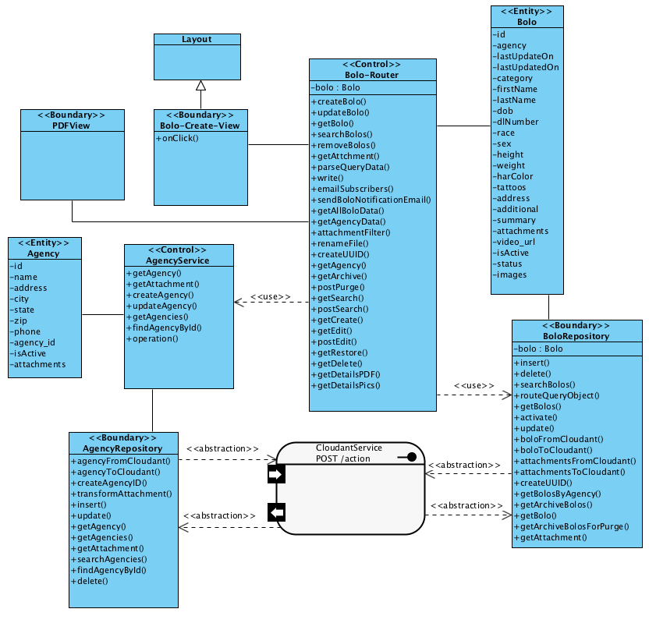

Figure 22 - Class diagram for Render BOLO Without Storing

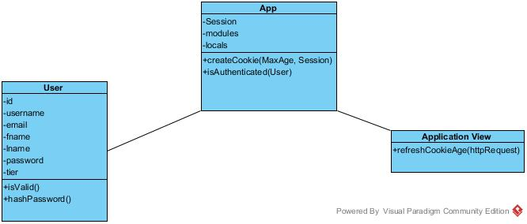

Figure 23 - Class diagram for Application Timeout

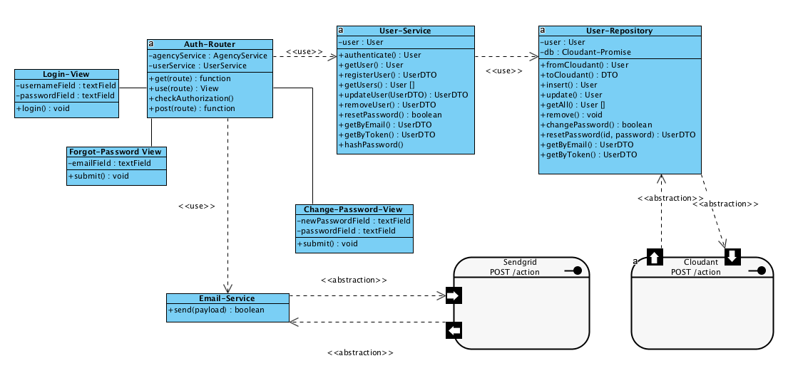

Figure 24 - Class Diagram for Reset Forgotten Password

### Dynamic UML Diagrams

Note* “user” actors represent any type of user. “Officer” does the same given that all other types of user have officer rights as well. Thus, ‘Ófficer’ and ‘user’ mean the same.

Note* ‘“Root Administrator” is often defined as “Root.”

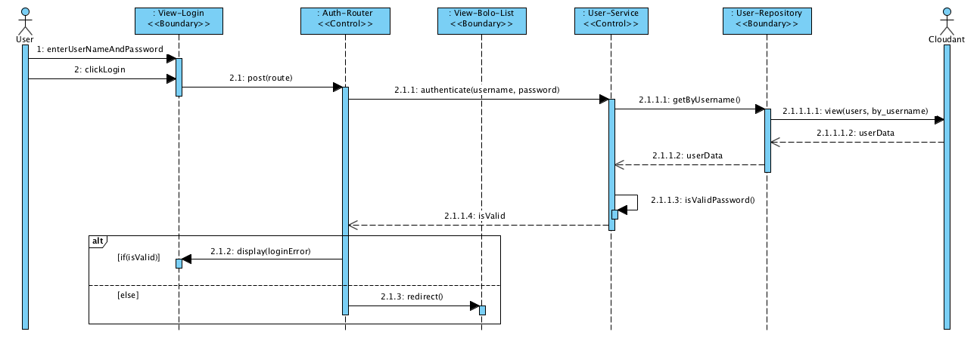

Figure 25 - Sequence diagram for viewing Aesthetic Design of system

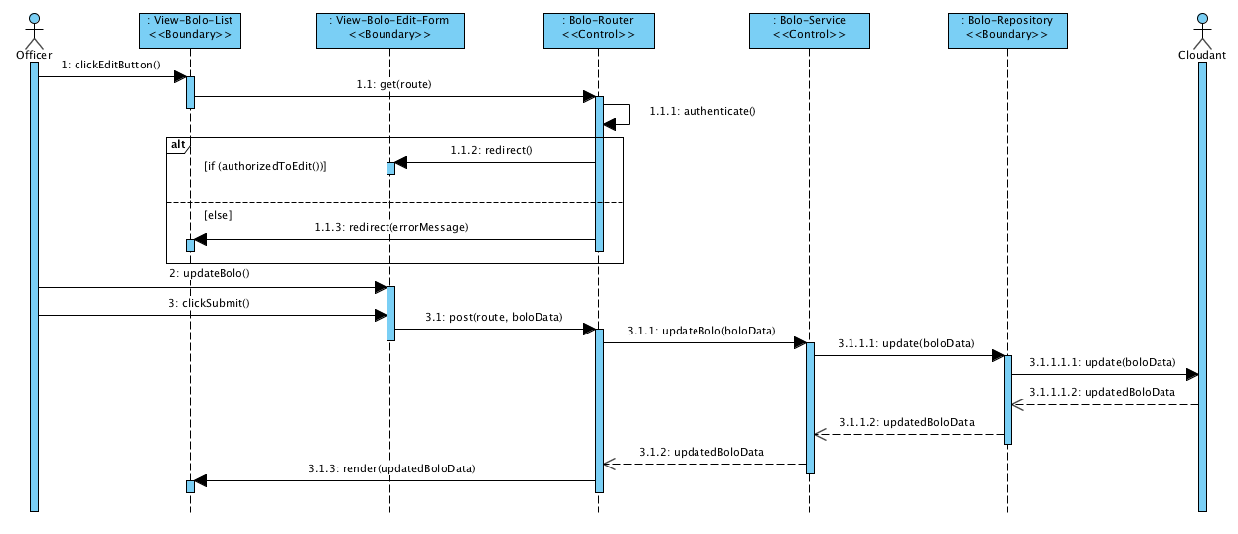

Figure 26 - Sequence diagram for Edit Own BOLO

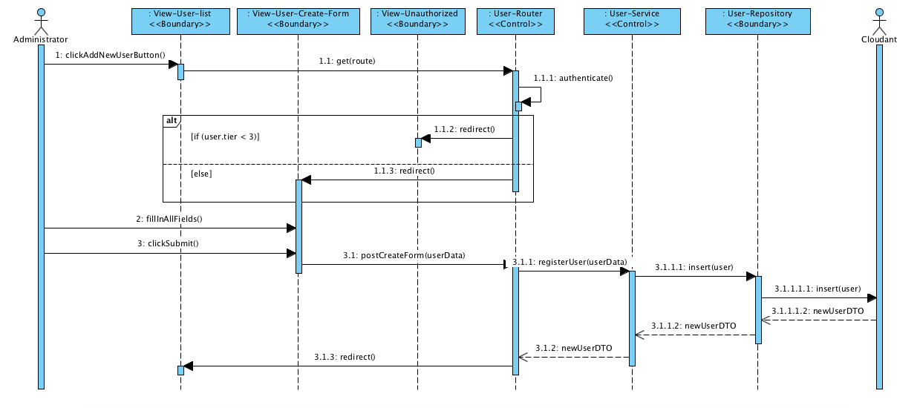

Figure 27 - Sequence diagram for Create User Within Agency

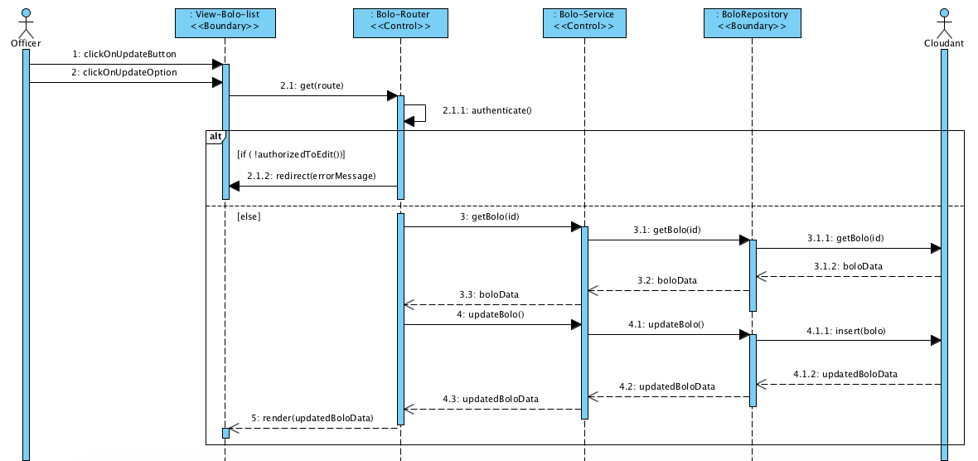

Figure 28 - Sequence diagram for Update BOLO Instantly

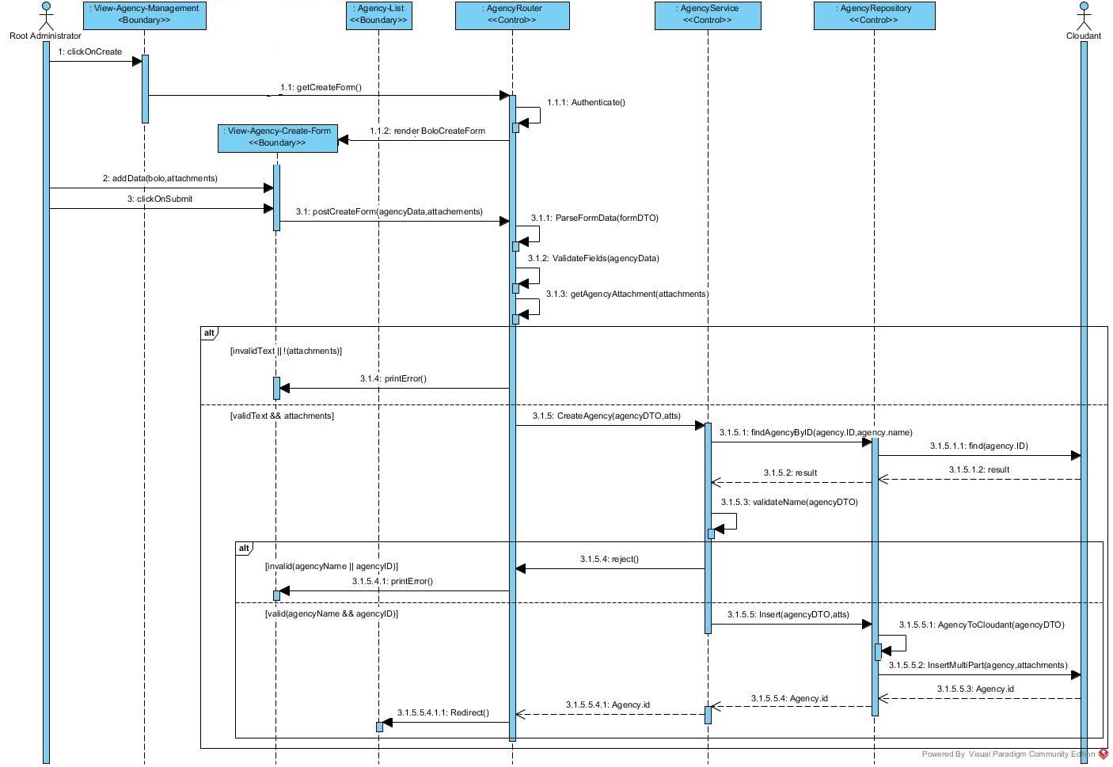

Figure 29 - Sequence diagram for Create Agency

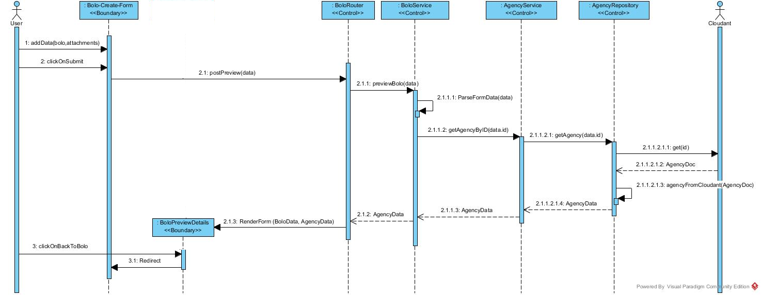

Figure 30 - Sequence diagram for Preview BOLO Before Creation

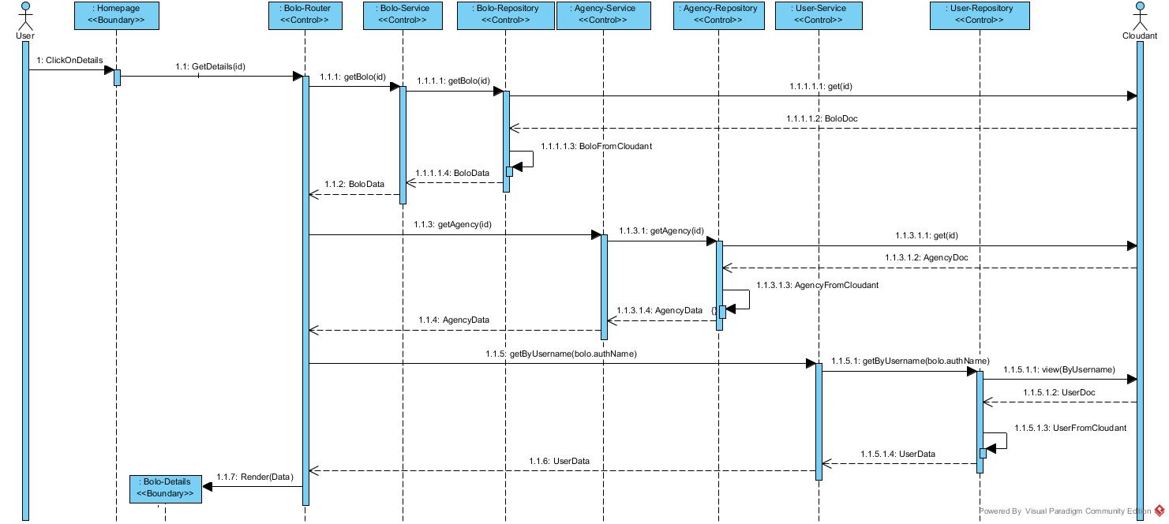

Figure 31 - Sequence diagram for View BOLO Flyer

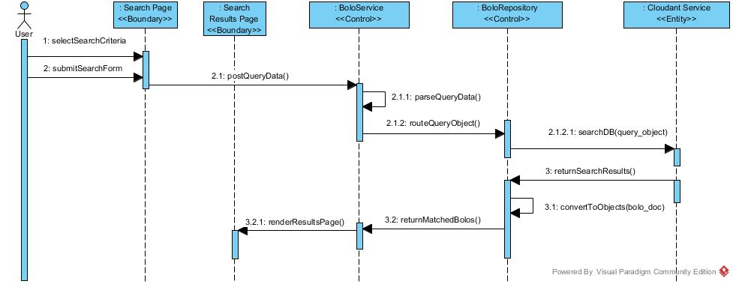

Figure 32 - Sequence diagram for Search BOLOs

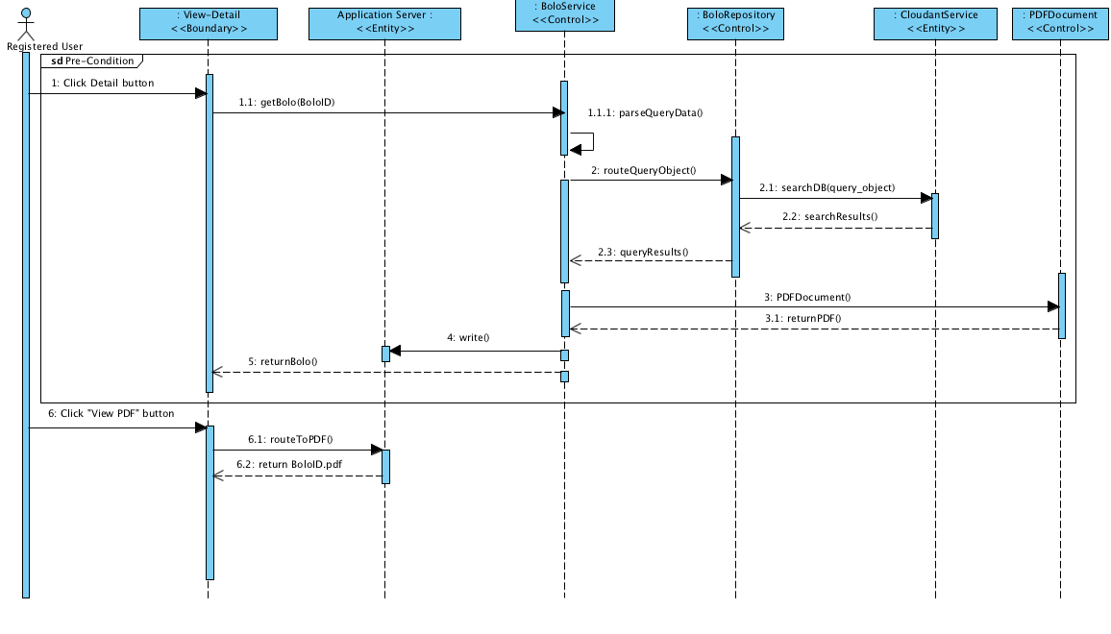

Figure 33 - Sequence diagram for View as PDF

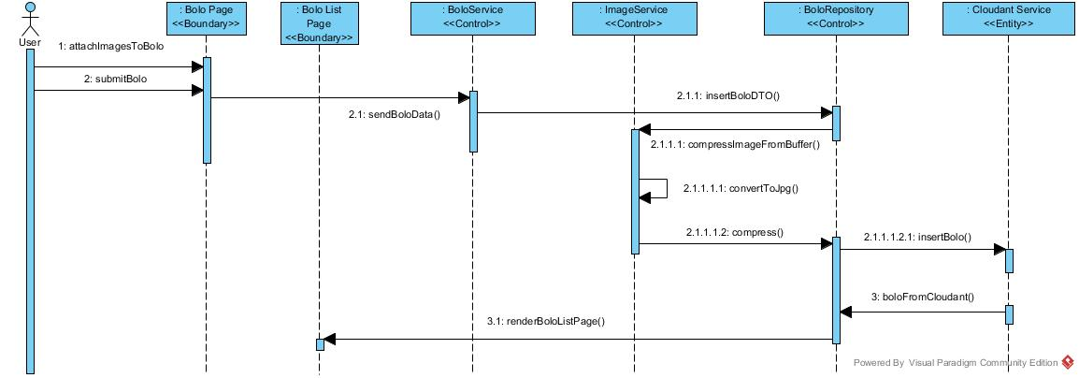

Figure 34 - Sequence diagram for Compress Image

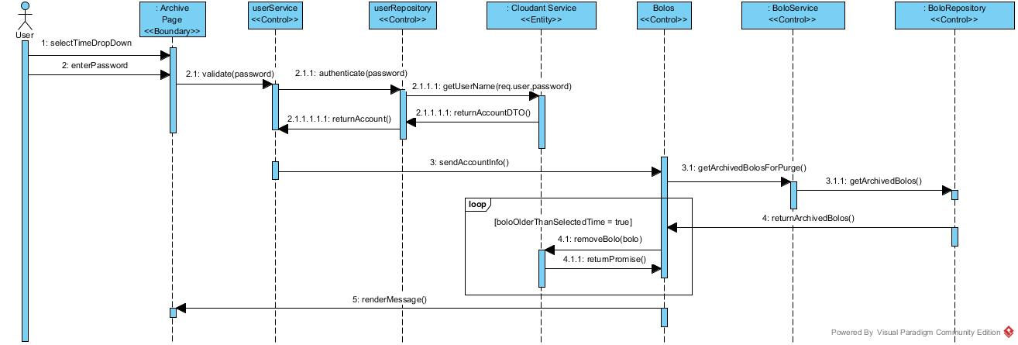

Figure 35 - Sequence diagram for Purge Archived BOLOs

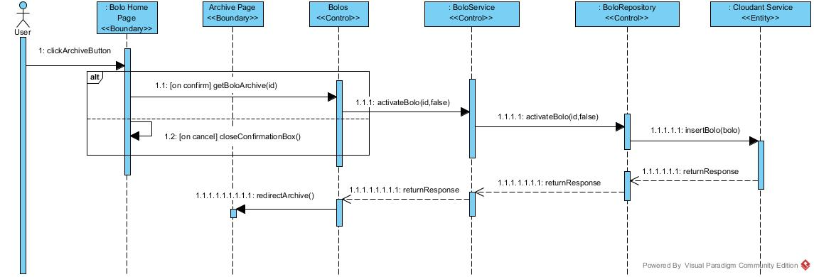

Figure 36 - Sequence diagram for Verify Archive BOLO

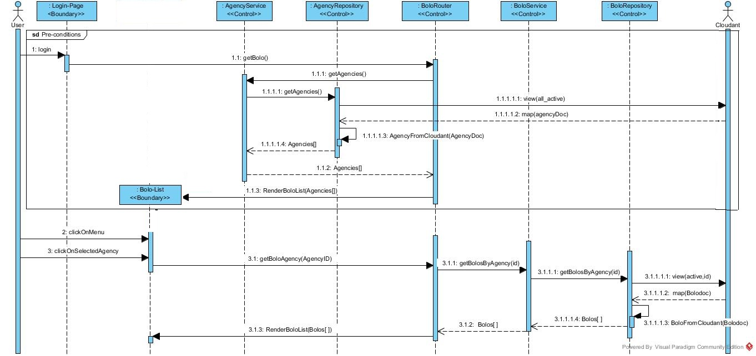

Figure 37 - Sequence diagram for Filter BOLOs By Agency

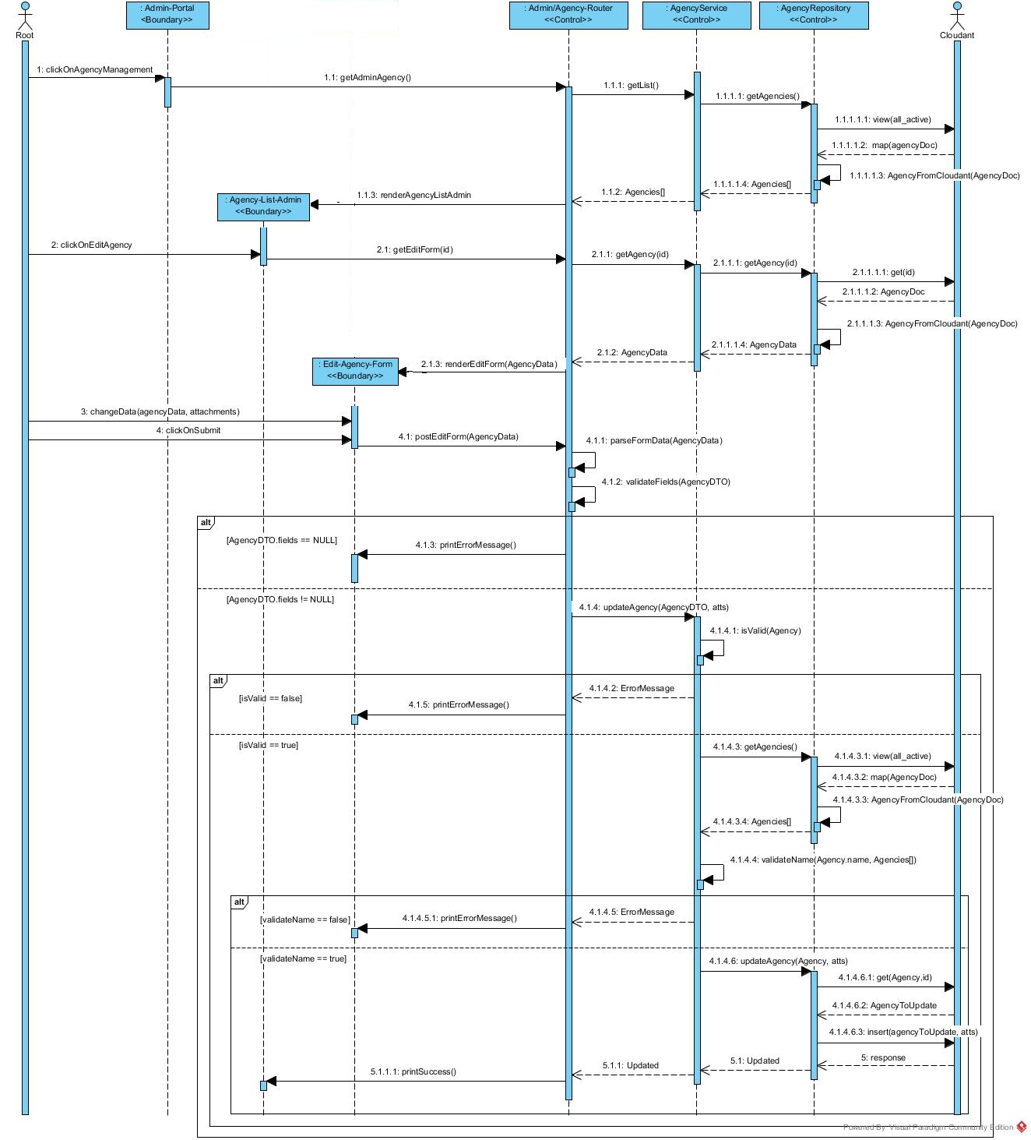

Figure 38 - Sequence diagram for Edit Agency

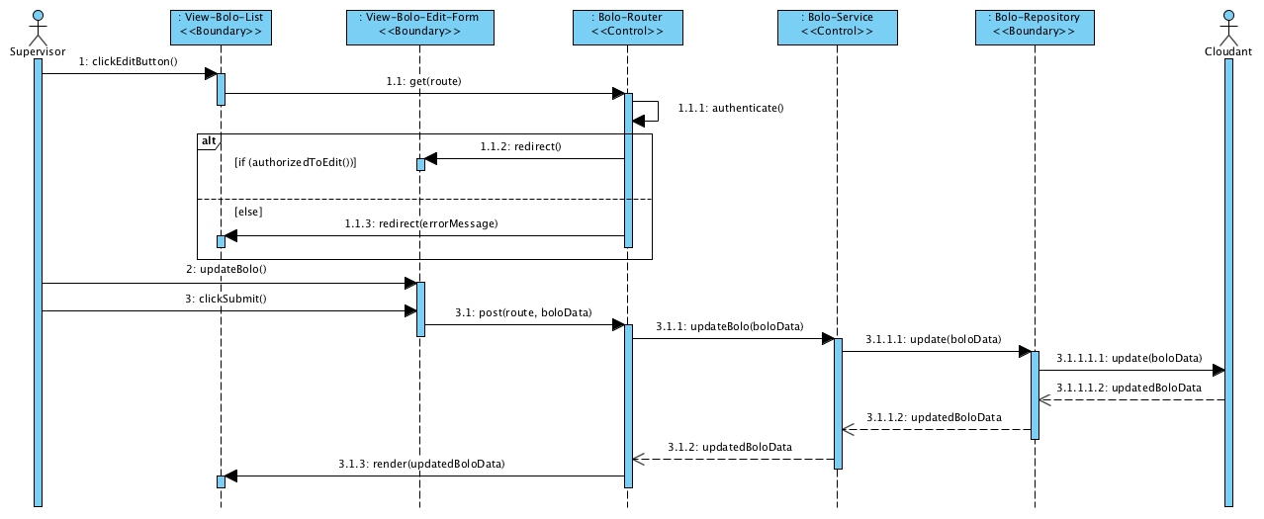

Figure 39 - Sequence diagram for Edit BOLO Within Agency

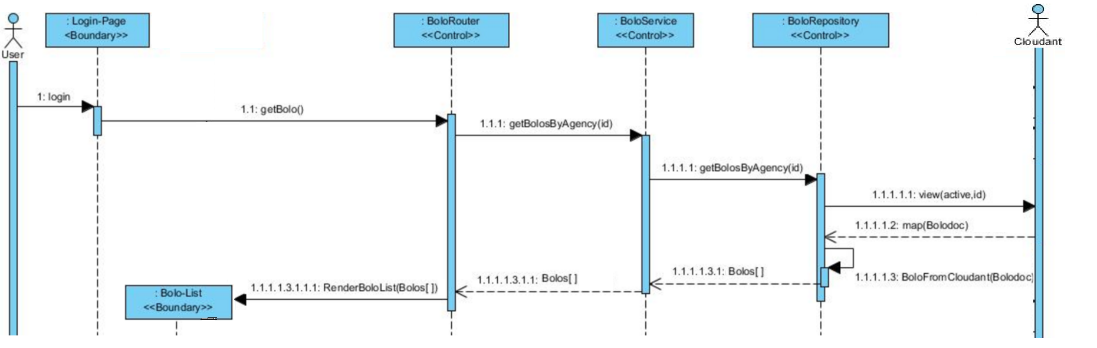

Figure 40 - Access BOLO Thumbnail Information

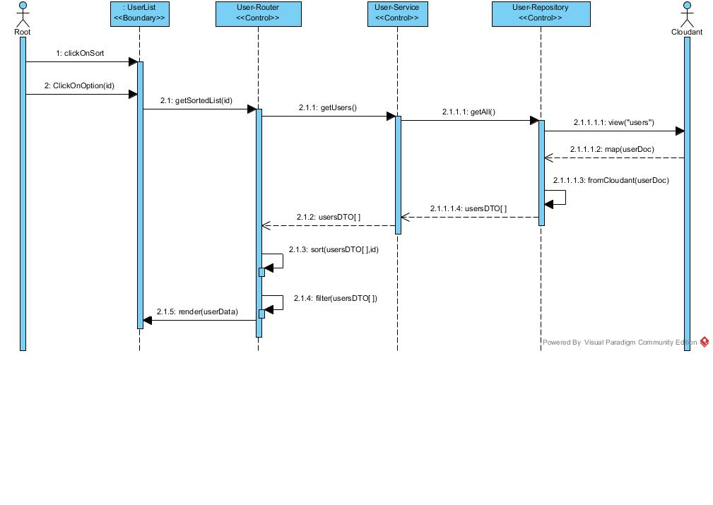

Figure 41 - Sequence diagram for Sort Users

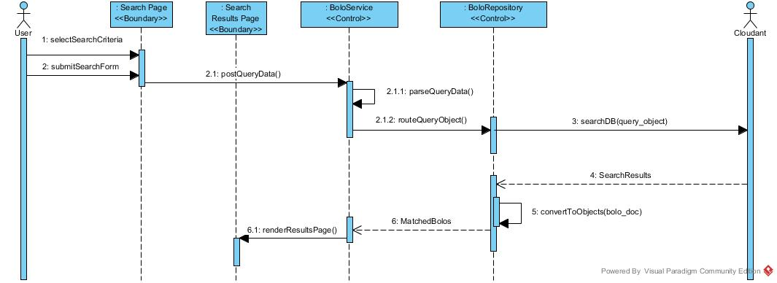

Figure 42 - Sequence diagram for Search BOLO By Agency

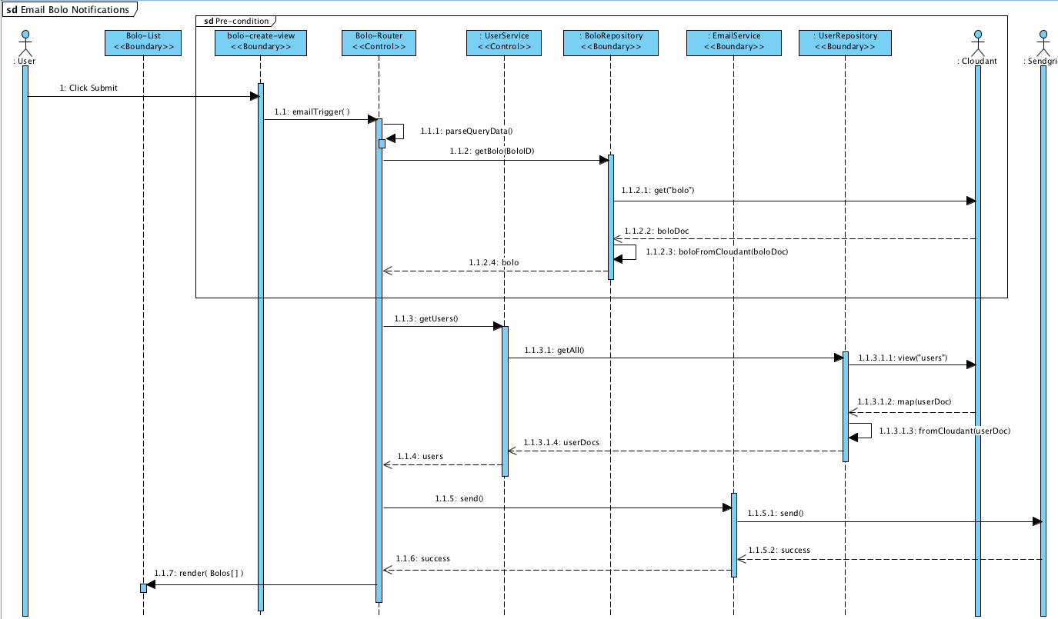

Figure 43 - Sequence diagram for Email New BOLO Notification

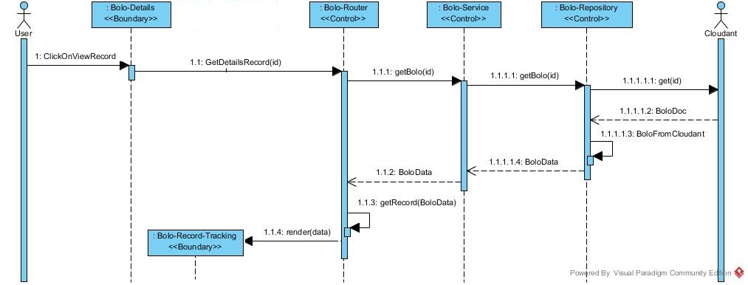

Figure 44 - Sequence diagram for Access BOLO Record Tracking

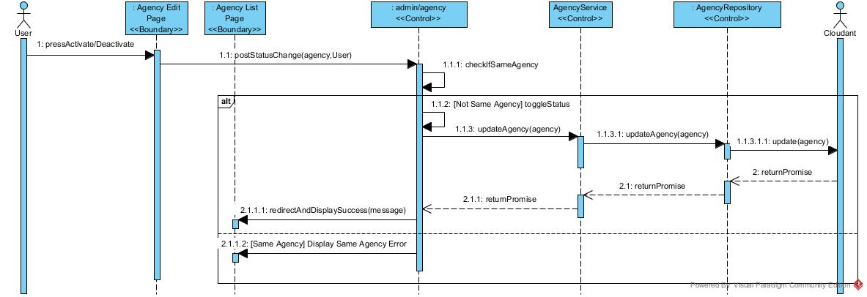

Figure 45 - Sequence diagram for Toggle Activation of an Agency

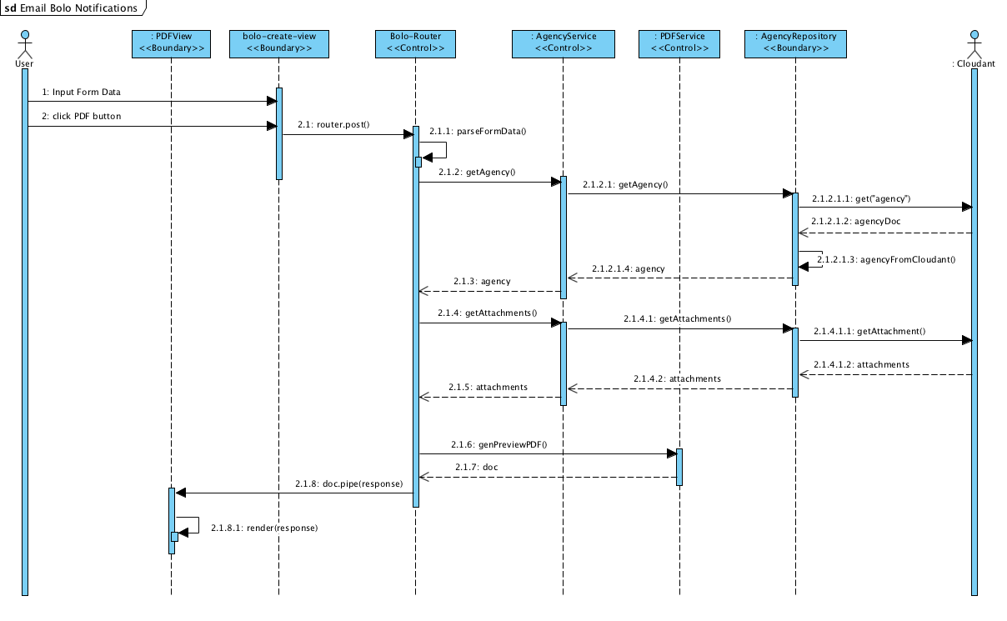

Figure 46 - Sequence diagram for Render BOLO Without Storing

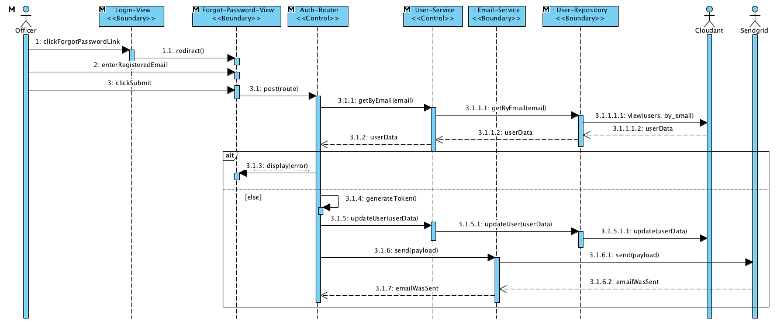

Figure 47 - Sequence diagram for Reset Forgotten Password

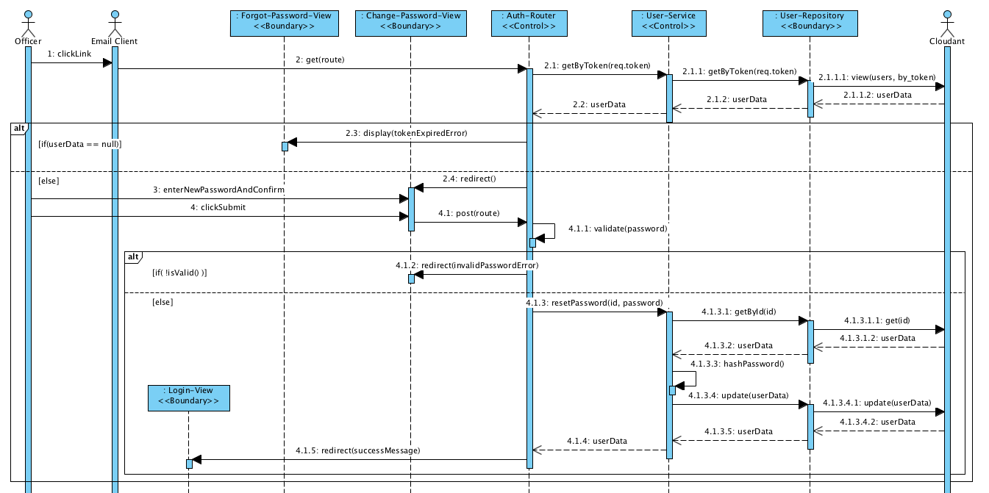

Figure 48 - Continued sequence diagram for Reset Forgotten Password

## Appendix B - User Interface Design

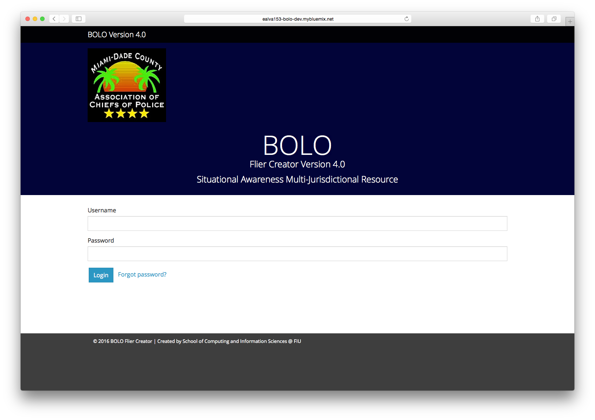

Figure 49- Login UI

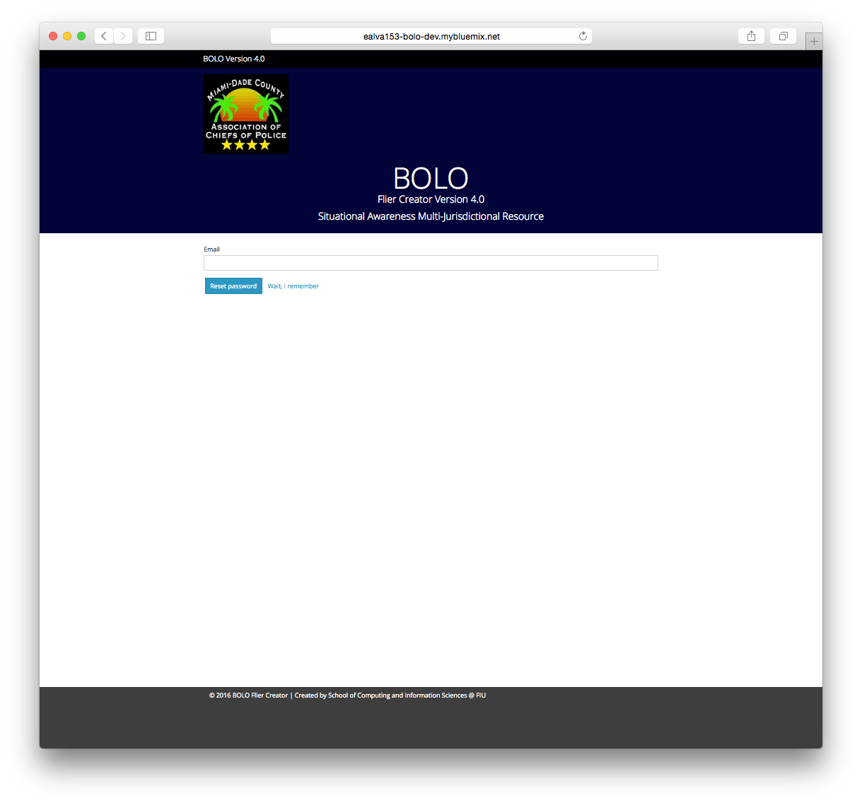

Figure 50 - Forgot Password

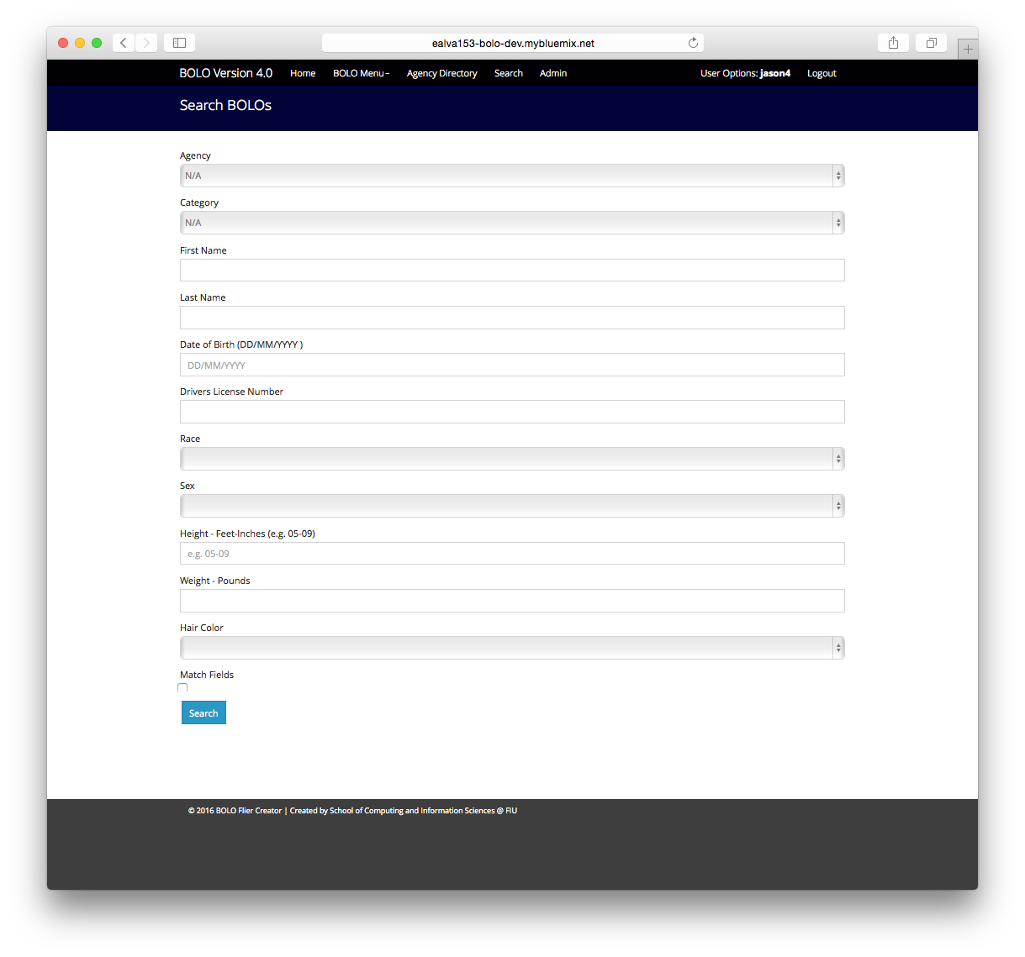

Figure 51 - Search BOLO

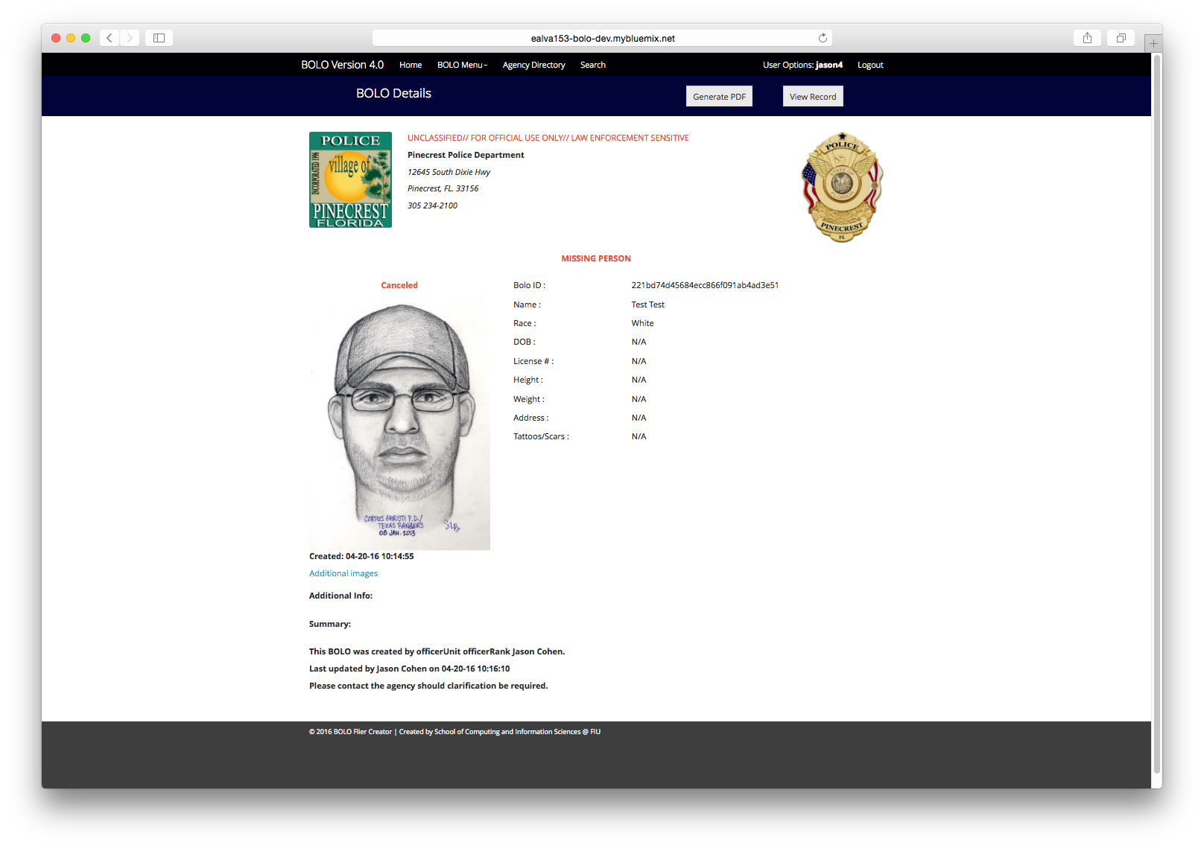

Figure 52 - BOLO Detail View

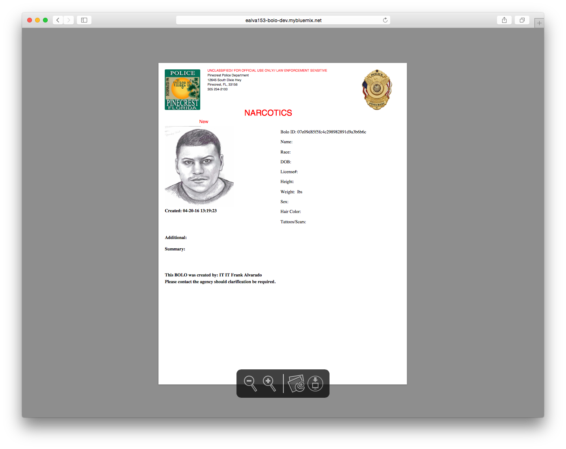

Figure 53 - View BOLO PDF

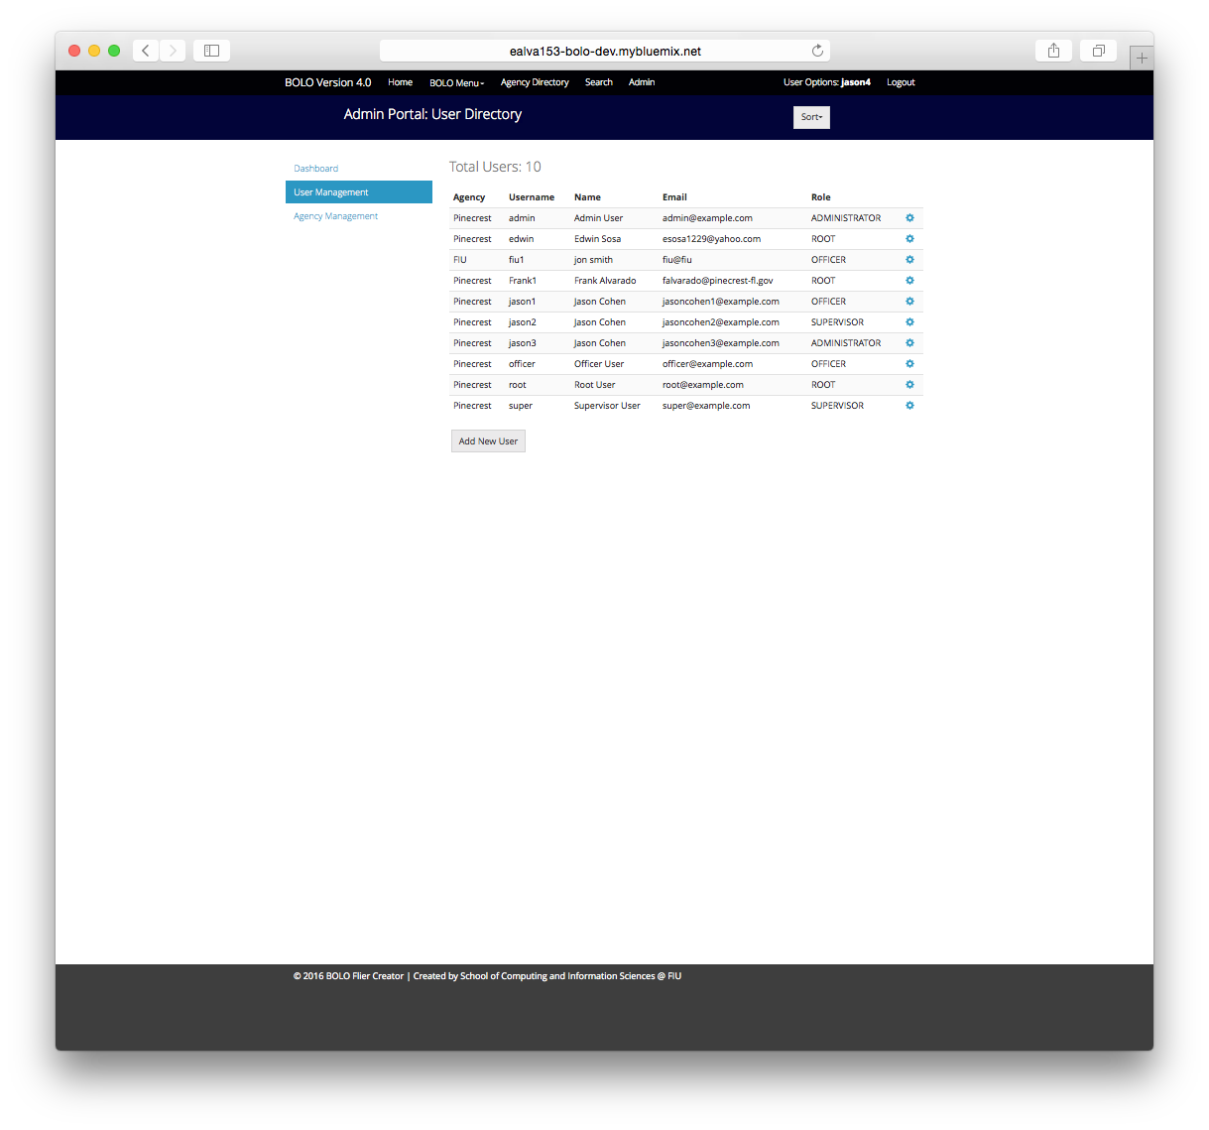

Figure 54 - User Management

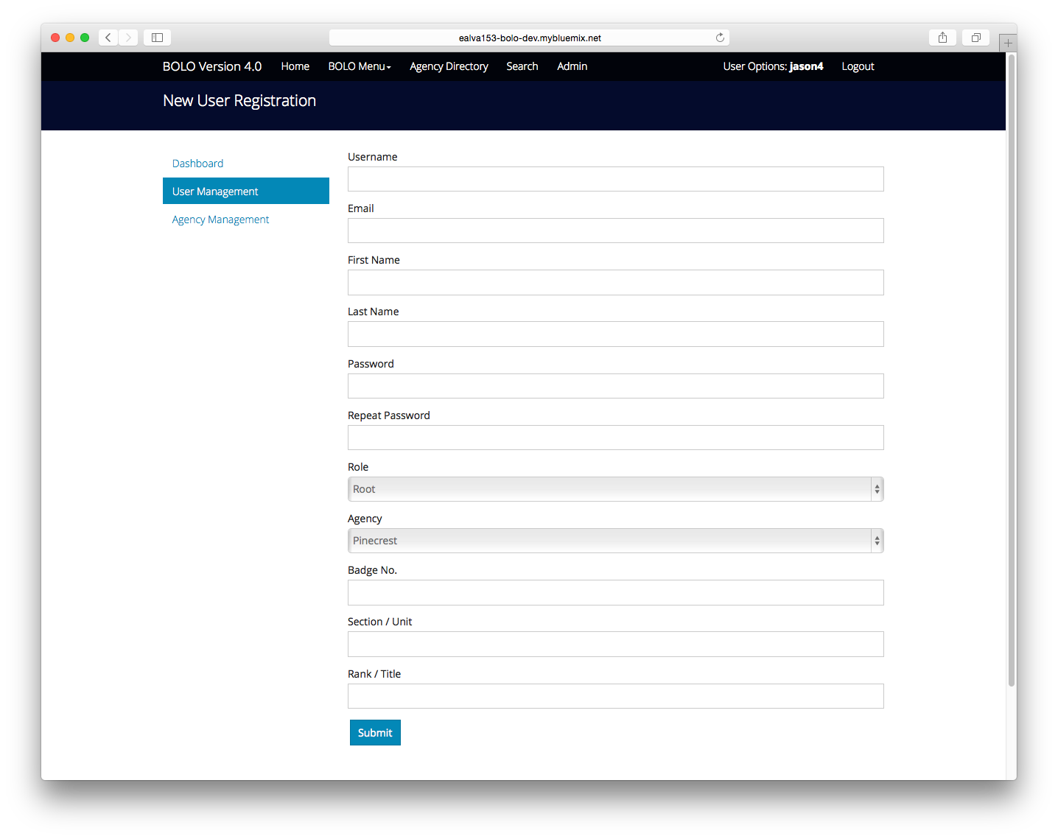

Figure 55 - Create New User

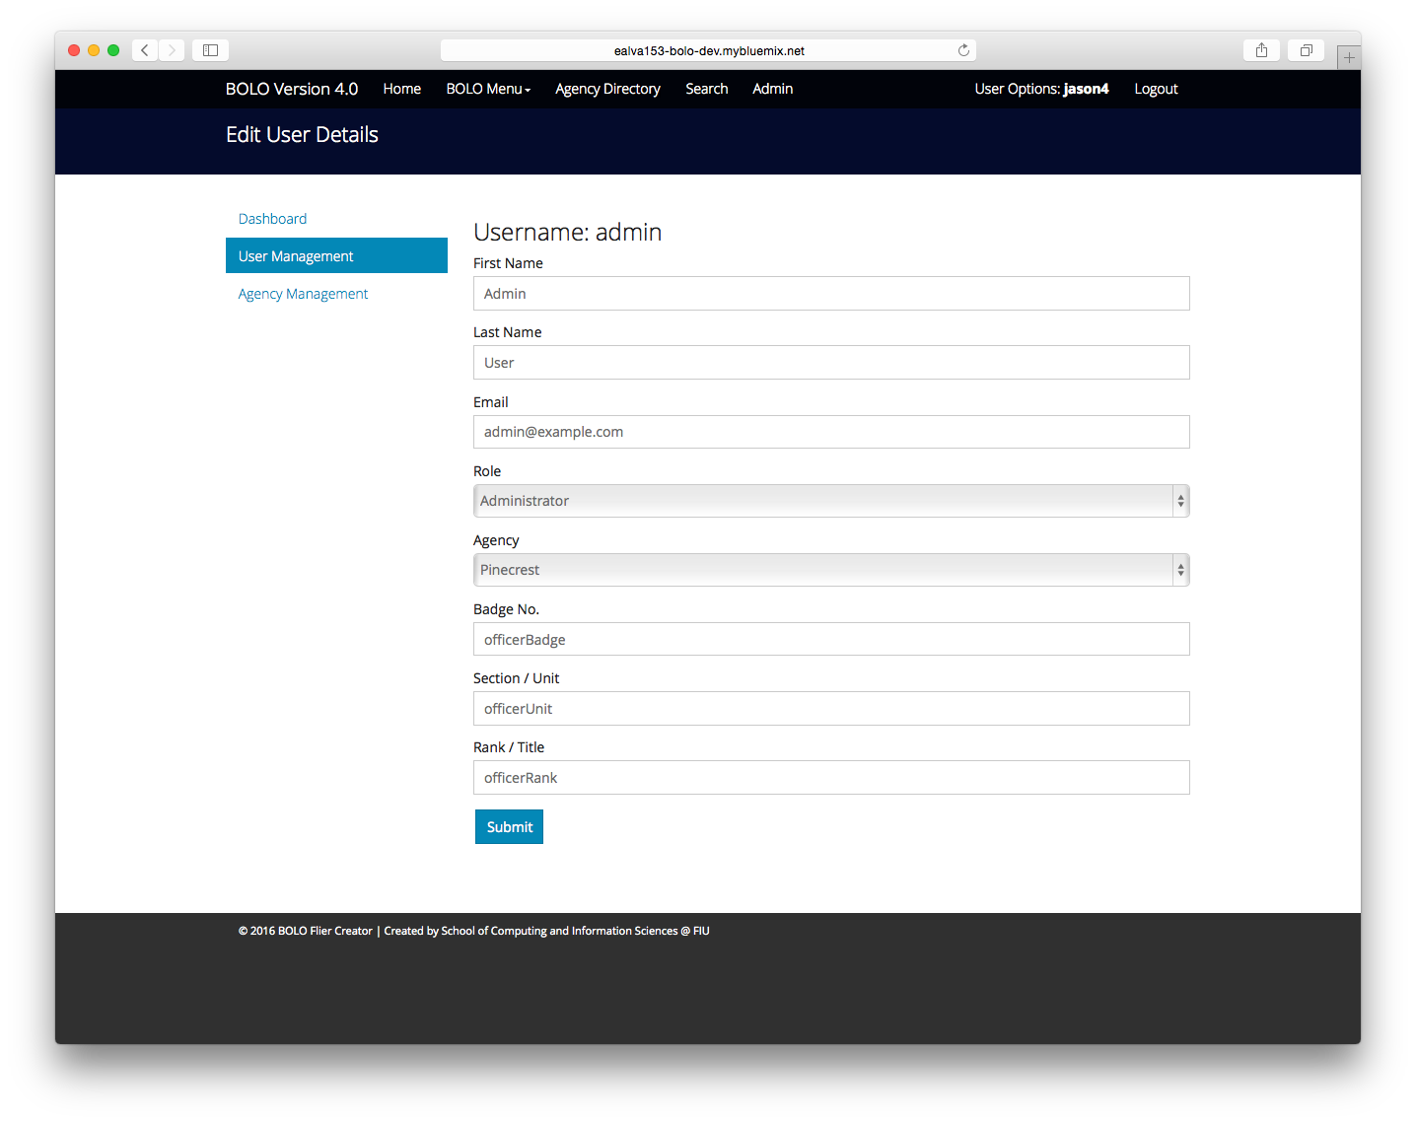

Figure 56 - Edit User

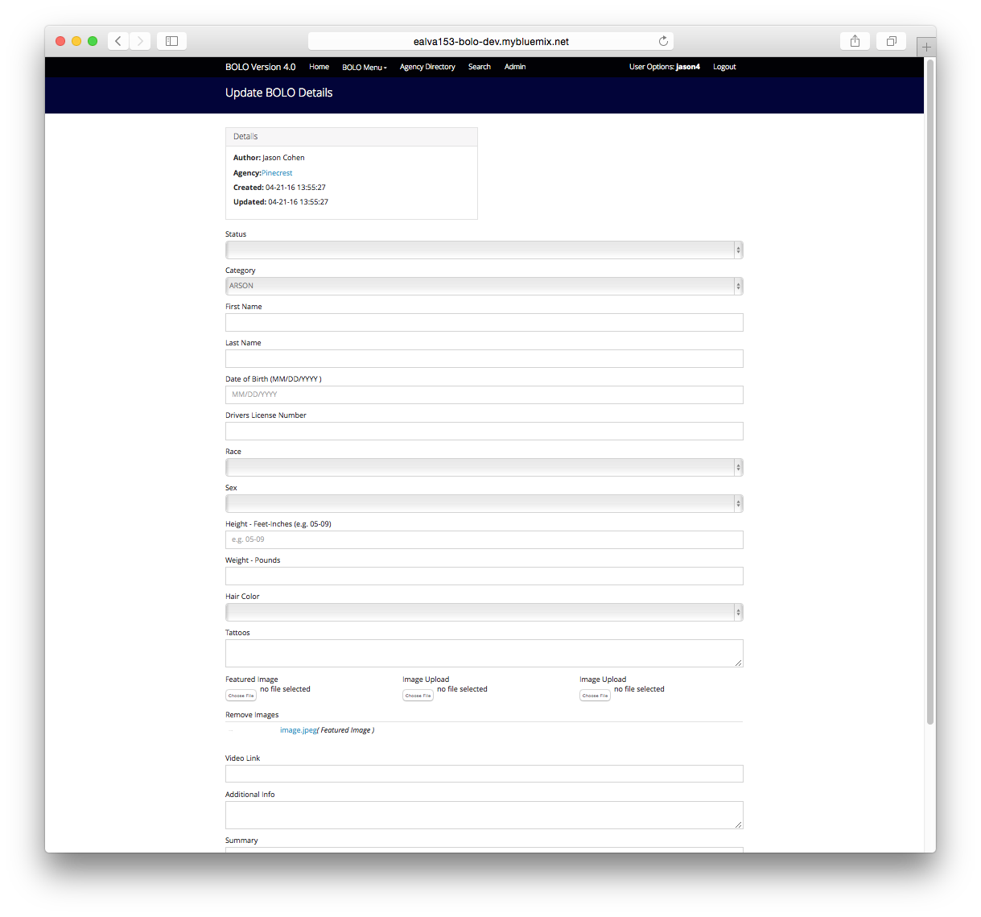

Figure 57 - Update BOLO Details



Figure 58 - Account Details

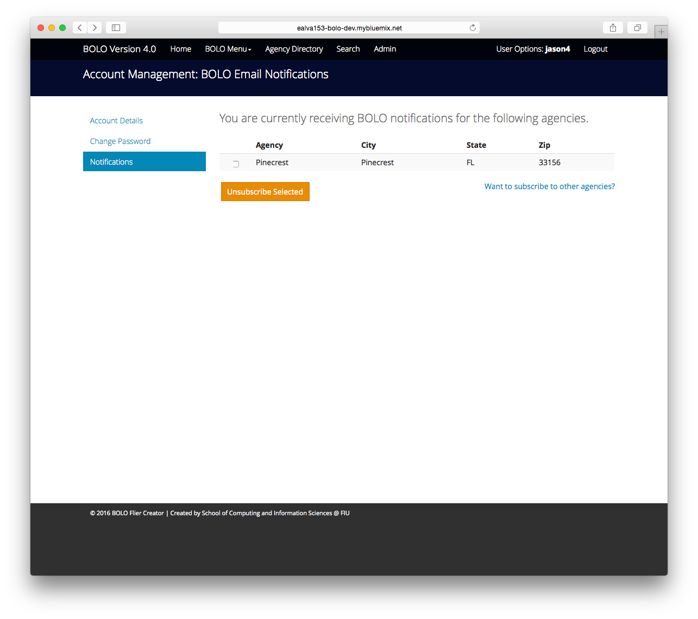

Figure 59 - Notification List

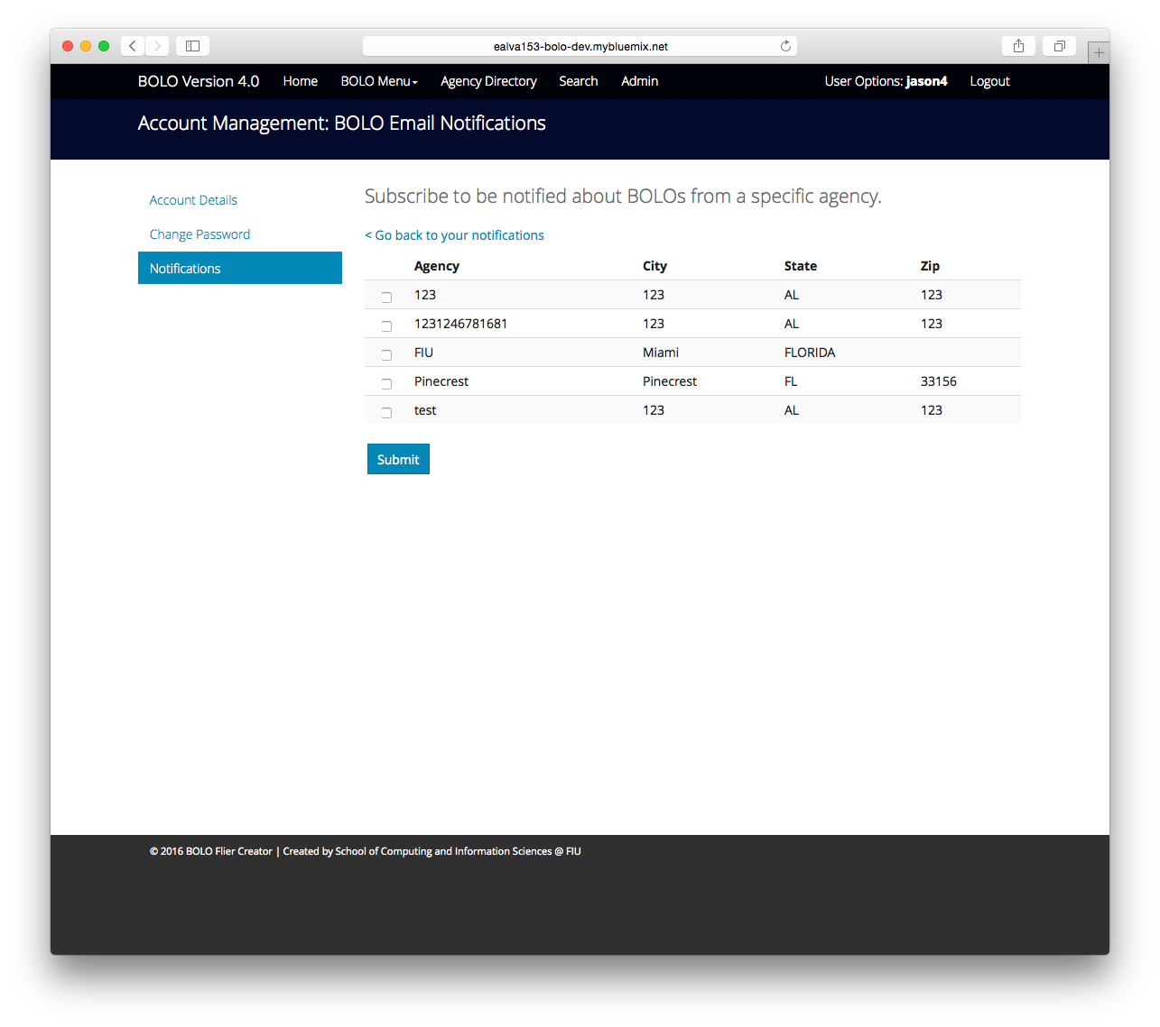

Figure 60 - Notification Management

## Appendix C - Sprint Review Reports

**Sprint 1 Report**

Date: 01/28/2016

Attendees: Edwin, Alejandro, Leonardo, Piero

Start time: 3:15 pm

End time: 4:30 pm

After a show and tell presentation, the implementation of the following user stories were accepted by the product owners:

* User Story #589
* User Story #598
* User Story #593

The following ones were rejected and moved back to the product backlog to be assigned to a future sprint at a future Spring Planning meeting.

* User Story #610
  + Reason for rejection:
    - Server side implementation for connection to SendGrid
    - Windows doesn’t have default PDF Printer to print from IE 9+
  + How this should be reflected on the user story definition in Mingle:
    - User Story#610 will go back to product backlog
    - User Story #610 will be put in sprint 2 (high priority as per Product Owner)

**Sprint 2 Report**

Attendees: Edwin, Alejandro, Leonardo, Piero

Start time: 3:15 pm

End time: 4:30 pm

After a show and tell presentation, the implementation of the following user stories were accepted by the product owners:

* User Story #610
* User Story #743
* User Story #750
* User Story #752

**Sprint 3 Report**

Date: 02/25/2016

Attendees: Edwin, Alejandro, Leonardo, Piero

Start time: 3:15 pm

End time: 5:30 pm

After a show and tell presentation, the implementation of the following user stories were accepted by the product owners:

* User Story #754(includes: #820, #821, #822)
* User Story #575
* User Story #787

The following ones were not presented since they had not been integrated to the system even though they had been implemented successfully. The owners will be given access to them on 03/02/2016 when the system is deployed.

* User Story #777
* User Story #602

**Sprint 4 Report**

Date: 03/10/2016

Attendees: Edwin, Alejandro, Leonardo, Piero

Start time: 3:15 pm

End time: 4:30 pm

After a show and tell presentation, the implementation of the following user stories were accepted by the product owners:

* User Story #777
* User Story #602
* User Story #814
* User story #609

**Sprint 5 Report**

Date: 03/31/2016

Attendees: Edwin, Alejandro, Leonardo, Piero

Start time: 3:15 pm

End time: 4:30 pm

After a show and tell presentation, the implementation of the following user stories were accepted by the product owners:

* User Story #615
* User Story #607
* User Story #812

**Sprint 6 Report**

Date: 04/14/2016

Attendees: Edwin, Alejandro, Leonardo, Piero

Start time: 3:15 pm

End time: 4:30 pm

After a show and tell presentation, the implementation of the following user stories were accepted by the product owners:

* User Story #781 Render BOLO PDF
* User Story #611 Access BOLO Record Tracking
* User Story #613 Toggle Activation of an Agency
* User Story #603 Edit Own Bolo

**Sprint 7 Report**

Date: 04/28/2016

Attendees: Edwin, Alejandro, Leonardo, Piero

Start time: 3:15 pm

End time: 6:30 pm

The system was deployed successfully on the owner’s Bluemix account. The product owners expressed their satisfaction with the final product and encouraged the team members to present their work to several other city authorities.

## Appendix D - Sprint Retrospective Reports

**Sprint 1 Retrospective**

Date: 02/01/2016

Attendees: Edwin, Alejandro, Leonardo, Piero

Start time: 11:00 pm

End time: 12:00 pm

What went wrong?

* The team is moving along the user story completion rate currently at 1 per week per contributor
* Majority of user stories are being implemented on time
* Each member contributed during agreed scheduled.
* Clarification of save to PDF solution occurred halfway past sprint 1
  + Led to conclusion that currently implementation of user story #610

must be re-thought.

What went right?

* Product Owner approved of current finished user stories.

How to address the issues in the next sprint?

* Follow software engineering procedures and proper iteration
  + We should not jump right into coding without planning how the user will interact with the system (i.e. - Use Cases, Sequence Diagrams & Class Diagrams)
* How to improve the product?
  + Implement Tier permissions
  + System constraint for unique agency

**Sprint 2 Retrospective**

Date: 02/13/2016

Attendees: Alejandro, Edwin, Leonardo, Piero

Start time: 7:00pm

End time: 9:00pm

What went wrong?

* Did we do a good job estimating our team's velocity?
  + Current rate is approximately completing one user story per contributor per week
* Did we do a good job estimating the points (time required) for each user story?
  + Based on the previous sprint, the team was able to improve its ability to foresee how much could be done during the current one.
* Did each team member work as scheduled?
  + All contributors worked together as per required overlap times and as per submitted schedules

What went right?

* Contributors continue to progress with user stories effectively.

How to address the issues in the next sprint?

* How to improve the process?
  + It is essential to figure out how to perform unit and integration testing.
  + It is necessary to consolidate individual changes made to the code by merging all personal branches with master in order to gain access to an updated version of the system.
* How to improve the product?
  + Client side form validation for new agency creation
    - server side validation already implemented

**Sprint 3 Retrospective**

Date: 02/26/16

Attendees: Leonardo, Edwin, Piero, Alejandro

Start time: 7:00PM

End time: 10:00PM

What went wrong?

* Did we do a good job estimating our team's velocity?
  + Yes, we had an average story completion rate of one story per week.
* Did we do a good job estimating the points (time required) for each user story?
  + Yes a good job was done estimating the points. Although, user story #777 StylizePDF took longer than anticipated. Images that are not written to the application file structure caused the need for implementation of a buffer/stream of the image to be passed to image() function form the pdfkit library.
* Did each team member work as scheduled?
  + Yes, each Team member worked according to the planned team schedule.
* Note:
  + For future sprints, more planning must be done for Sprint Review demos.

What went right?

* Pace of work

How to address the issues in the next sprint?

* How to improve the process?
  + During Team meetings on Tuesday nights, the team must decide a plan on what is going to be demoed for the product owner and in what order, and then, do a mock presentation.
* How to improve the product?
  + As per mentors, have a “Clean Up” story that will handle all small details that must be fixed within the system.
  + As per mentors, the product must be deployed to allow the product owners to test out the system while in production.

**Sprint 4 Retrospective**

Date: 03/11/2016

Attendees: Edwin, Alejandro, Leonardo, Piero.

Start time: 19:00

End time: 21:00

What went wrong?

* Did we do a good job estimating our team's velocity?
  + Yes, more user stories than anticipated were completed.
* Did we do a good job estimating the points (time required) for each user story?
  + Yes, user stories #814, #606 and #609 were implemented within the first two days of the sprint.
  + User stories #604, #613, #811, and #779 were successfully implemented even though they had not been planned to be finished by the end of the sprint.
  + User stories #763, #781, and #812 have been developed at a steady, efficient pace.
* Did each team member work as scheduled?
  + Yes, each team member completed at least one user story.
  + Each team member also contributed to different aspects of system development such as testing and bug fixing.

What went right?

* One of the team members was able to run the current tests and add more.
* Minor issues with CSS, routing, and overall flow of information were solved.
* BOLO detail views and content blocks were made dynamic.
* The team completed -or partially completed- up to nine user stories.

How to address the issues in the next sprint?

* How to improve the process?
  + Every team member should be able to run the current tests in order to contribute by adding more.
  + Minor issues such as discrepancies with the contents of the BOLO details page and the PDF must be taken care off in order to gain congruence.
* How to improve the product?
  + An universal test suite that all team members can run is needed.
  + PDF functionality and design need improvement.
  + Automated testing may facilitate and speed up the deployment process.

**Sprint 5 Retrospective**

Date: 04/01/2016

Attendees: Edwin, Alejandro, Leonardo, Piero

Start time: 19:40

End time: 20:00

What went wrong?

* Did we do a good job estimating our team's velocity?
  + Yes. Three of the user stories were successfully implemented. The remaining one was only missing tests.
* Did we do a good job estimating the points (time required) for each user story?
  + Yes. Almost every user story was completed.
* Did each team member work as scheduled?
  + User story #615 - Search BOLO By Agency was implemented within the second week of the sprint.
  + User story #607 - Sort Users was implemented swiftly with no bugs.
  + User Story #812 - Forgot My Password was implemented successfully with no delay.
  + User Story #763 - Sendgrid Implementation was brought to the point where only several integration tests are needed.
  + User stories #781: PDF Without Creating BOLO and #603: Agency Control Rules were moved to the following sprint.

What went right?

* A team member found a way to optimize the PDF functionality through the use of a new buffering system.
* The unit test suite was fixed for all team members to use.
* The system views were made dynamic to fit mobile usage.
* The team acquired a definitive idea on how to create cohesion in the UML documents.

How to address the issues in the next sprint?

* How to improve the process?
  + More attention needs to be given to testing. Integration testing needs to be implemented and more unit tests have to be added.
* How to improve the product?
  + The system has to be deployed on an account that belongs to the owner so that field tests can be made. This will provide enough information to fix any last minute bugs in the system.

**Sprint 6 Retrospective**

Date: 04/15/2016

Attendees: Piero, Alejandro, Edwin, Leonardo

Start time: 7:00pm

End time: 8:30pm

What went wrong?

* Overlapping functions were reimplemented causing one feature to break
* Stubs and mock objects for Integration Testing are not responding

What went right?

* Estimated team’s velocity accurately. (Average: 1 User Story per Sprint )
* Proper points were allotted to tasks and ultimately User Stories

How to address the issues in the next sprint?

* How to improve the process?
  + During code review, overlapping functions should be discussed by subject developers.
* How to improve the product?
  + Proper implementation of testing.

**Sprint 7 Retrospective**

Date: 04/30/2016

Attendees: Piero, Alejandro, Edwin, Leonardo

Start time: 7:00pm

End time: 8:30pm

The team reminisced on how the system looked when it was first provided. The amount of functionality that was added this semester is beyond what it was expected at first.

# References

Wilson, Doug (2016) body-parser source code (Version 1.13.2) [Source code]. <https://www.npmjs.com/package/body-parser>,

Mueller, Patrick (2016) cfenv source code (Version 1.0.3) [Source code]. <https://www.npmjs.com/package/body-parser> ,

Smith, J (2016) cloudant source code (Version 1.4.1) [Source code]. <https://www.npmjs.com/package/cloudant> ,

Smith, J (2016) cfenv source code (Version 1.0.3) [Source code]. <https://www.npmjs.com/package/cfenv> ,

**Libraries:**

"connect-flash": "^0.1.1",

"cookie-parser": "*",

"csurf": "^1.8.3",

"dotenv": "^1.2.0",

"errorhandler": "1.4.1",

"express": "4.12.x",

"express-session": "1.7.6",

"gm": "^1.21.1",

"iframe": "^0.3.1",

"imagemin": "^4.0.0",

"jade": "^1.11.0",

"jimp": "^0.2.9",

"lodash": "^3.10.1",

"method-override": "2.3.3",

"moment": "^2.10.6",

"morgan": "1.6.1",

"multiparty": "^4.1.2",

"node-phantom": "^0.2.5",

"node-uuid": "^1.4.3",

"node-wkhtml": "^0.1.0-alpha1",

"nodepdf": "1.2.1",

"passport": "^0.3.0",

"passport-local": "^1.0.0",

"pdfkit": "^0.7.2",

"phantomjs": "^2.1.3",

"promise": "^7.0.4",

"request": "^2.64.0",

"sendgrid": "^2.0.0",

"serve-favicon": "^2.3.0",

"socket.io": "^1.0.0",

"socket.io-express-session": "^0.1.3",

"validate.js": "^0.9.0",

"wkhtmltopdf": "^0.1.5"